**--------------------------------------------------- User Defined function------------------------------------------**

1. User Defined function

A sample program which demonstrate the use of function

Myfunc is the function name and “a” is the argument it takes

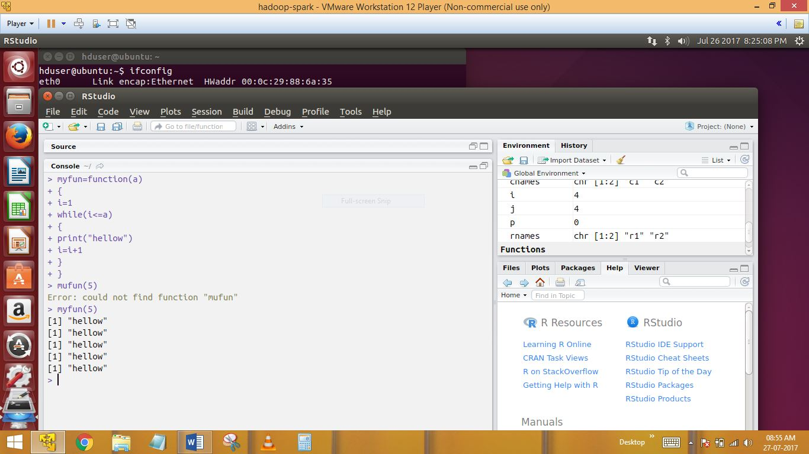

Descripion :  
Here calling a function , 5 is the value that gets passed to a..

2)First N natural Numbers

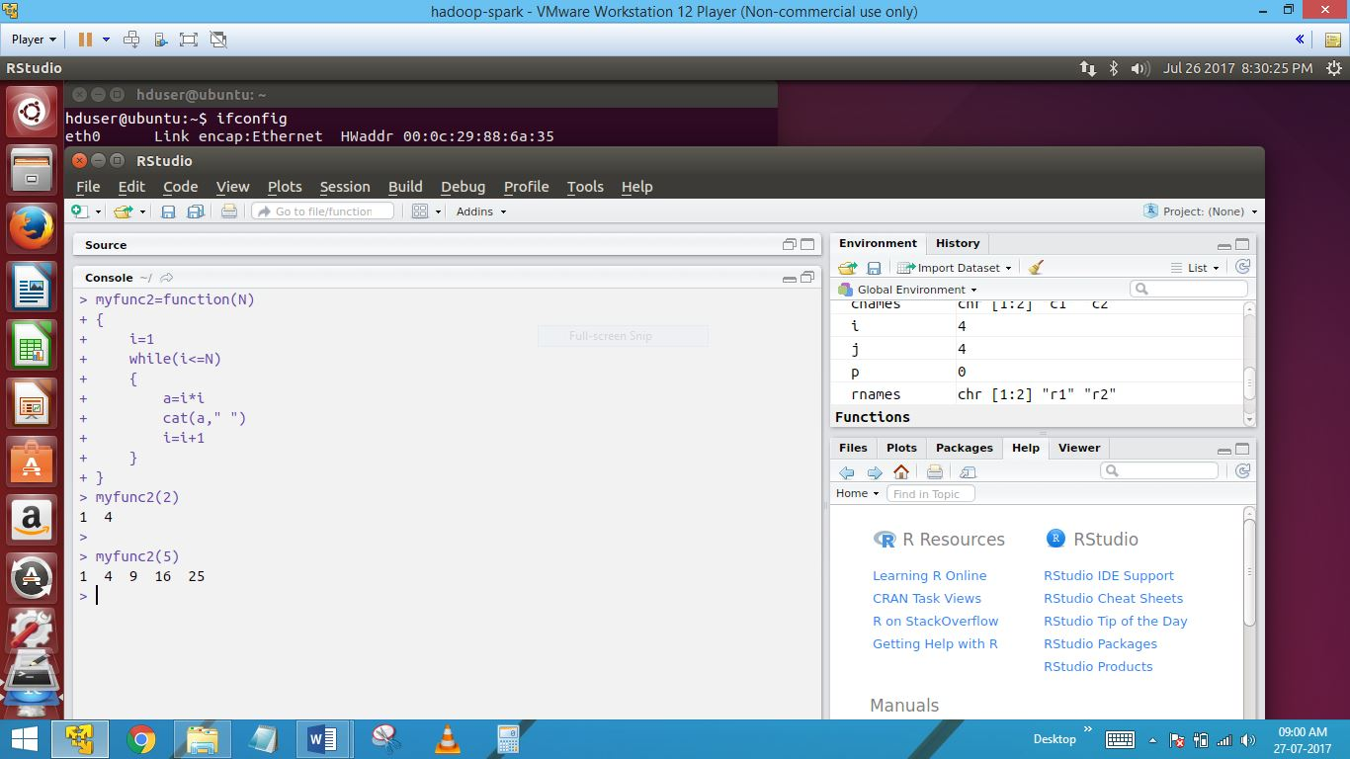

Description :

Here we use while loop when we get first N natural numbers, where N would be the argument the user passes to the function

3)Functions without arguments

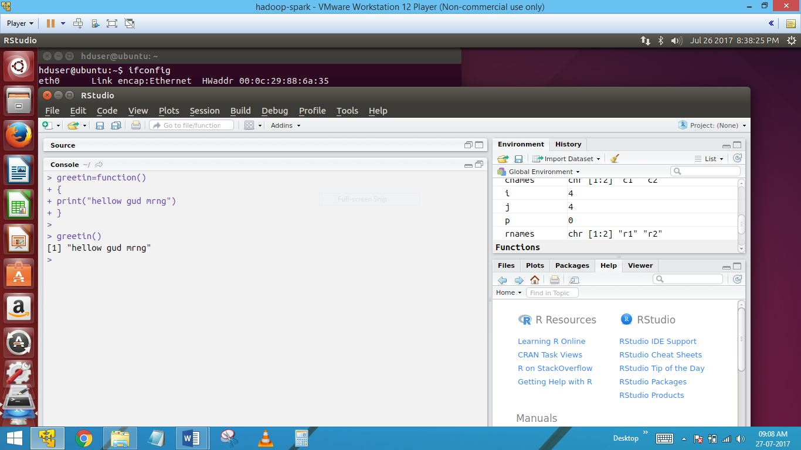

Calling a function from the function greeting…

4)function with default arguments

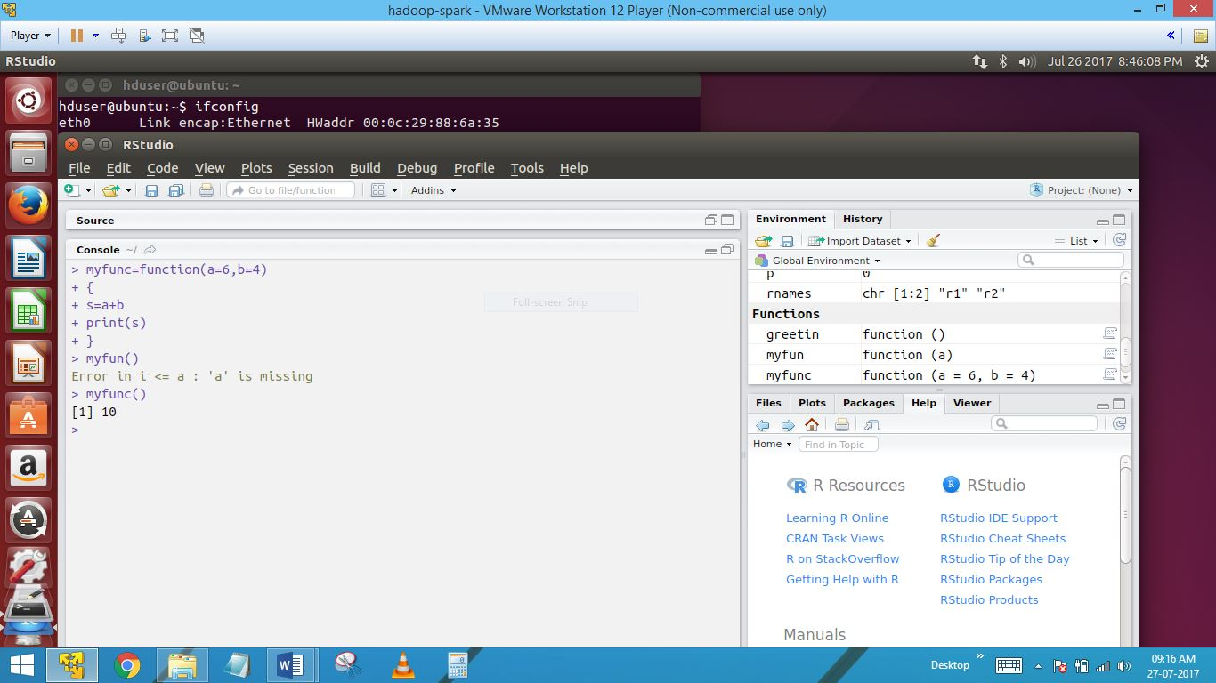

Here print directly with default argument a,b

5) function returning values in different ways

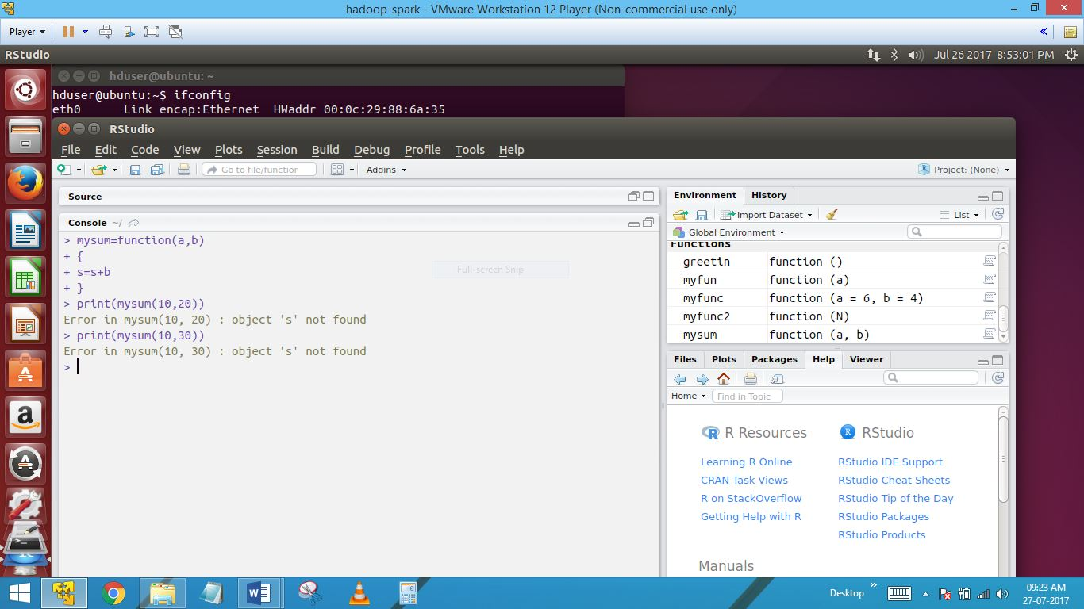

Automatically returning values in different ways like s=a+b & function calling for print (mysum(10,20)

6) function returning values in different ways

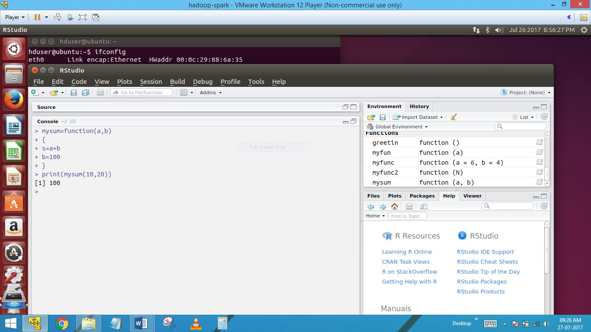

B is the last object in this block & b will be returned…function can return only one object at a time, in case you need to return more than one object, here we use vectors or lists..

7)write a program where a vector with 10 numbers is passed on to a user defined function increment every num

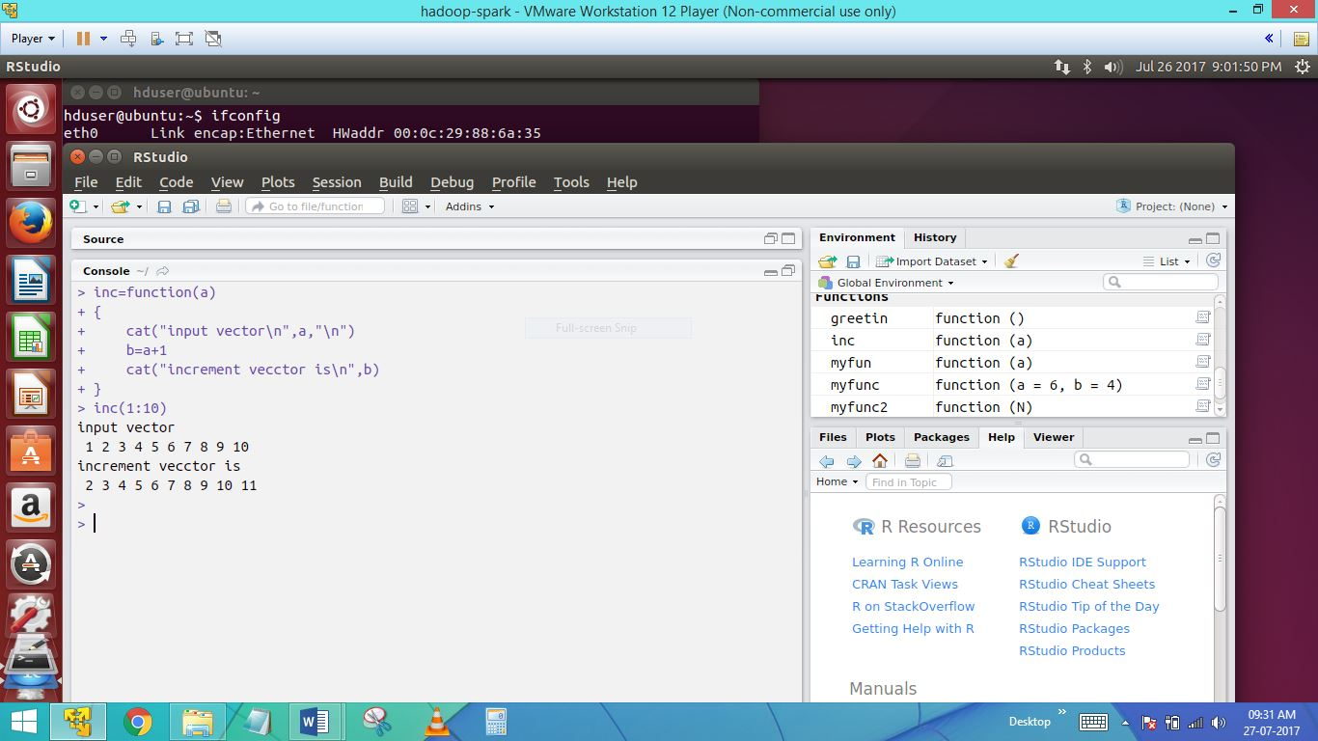

Here also increment by a=a+1 & incrementing vector is 2345678901011

**---------------------Passing variable number of arguments to a function ---------------------**

8)neo<-function(a,b,…)

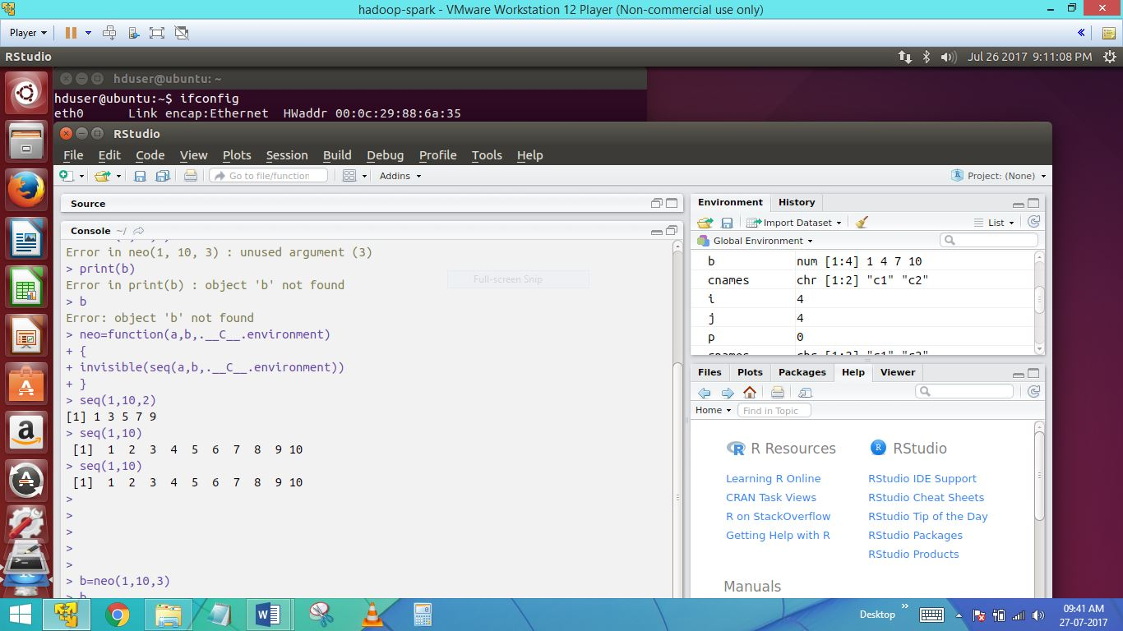

Neo is a function which can take 2 or 3 arguments

Invisible will not produce the o/p on the screen

**----------------------------------STRINGS-------------------------------------**

9)Strings

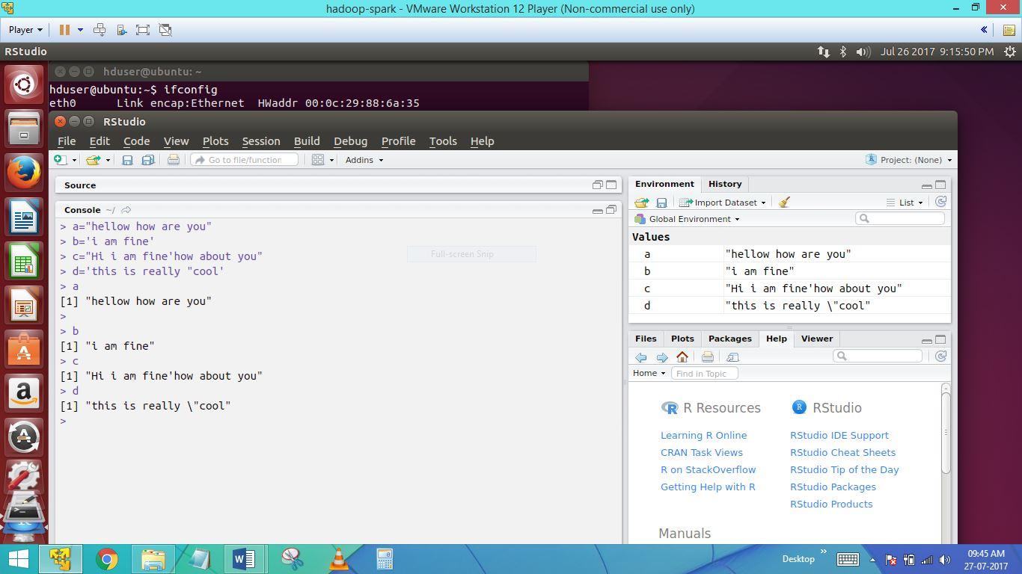

2 types of valid string in ” , ‘’ , in different ways..

10)string sep

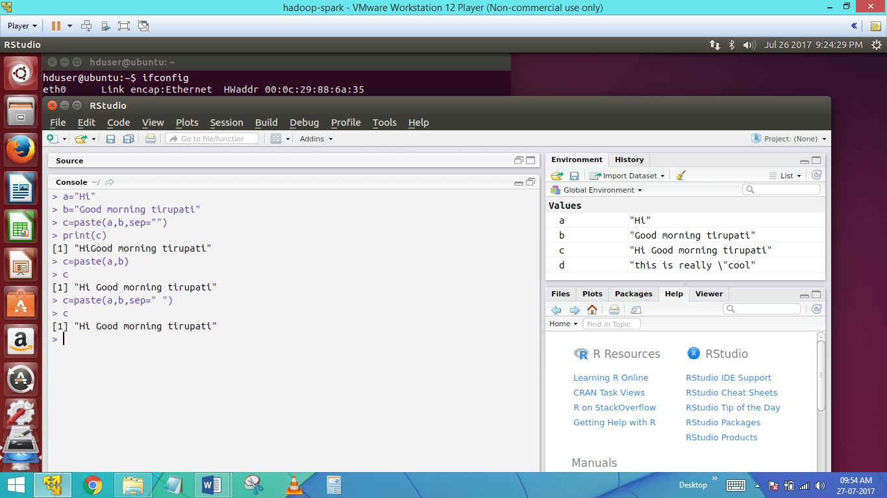

Sep argument is the separator which between the strings a,b for concatenation

11)string manipulation

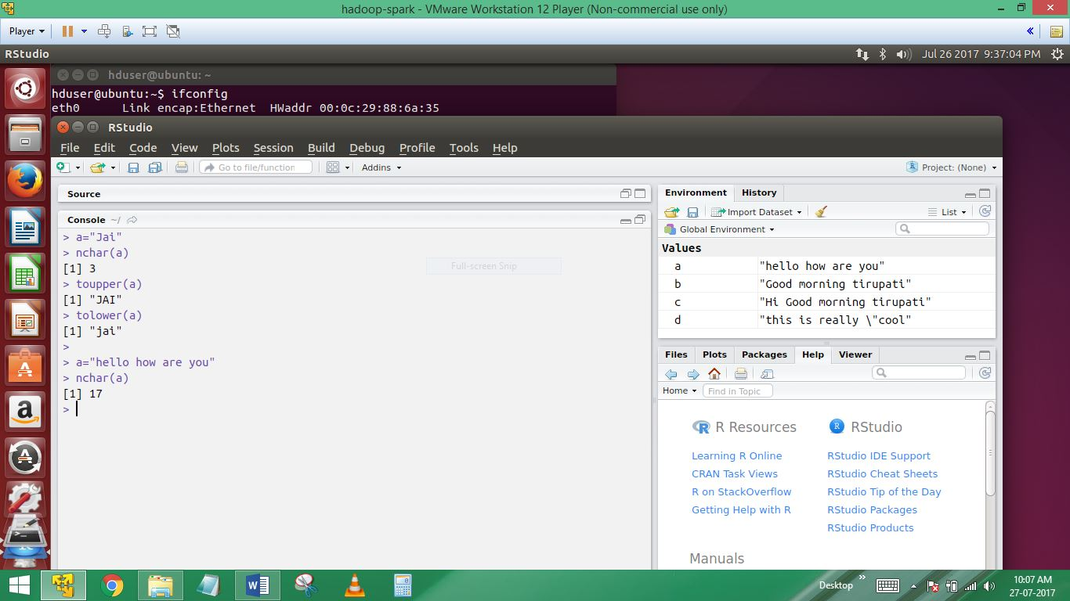

Can find upper case & lower case of letters in string, & count of the string also find out..

12)a=”hello how are you”

Nchar will give the count of total numbers of character including the space .how to find out only the total count of letters ignoring the space..

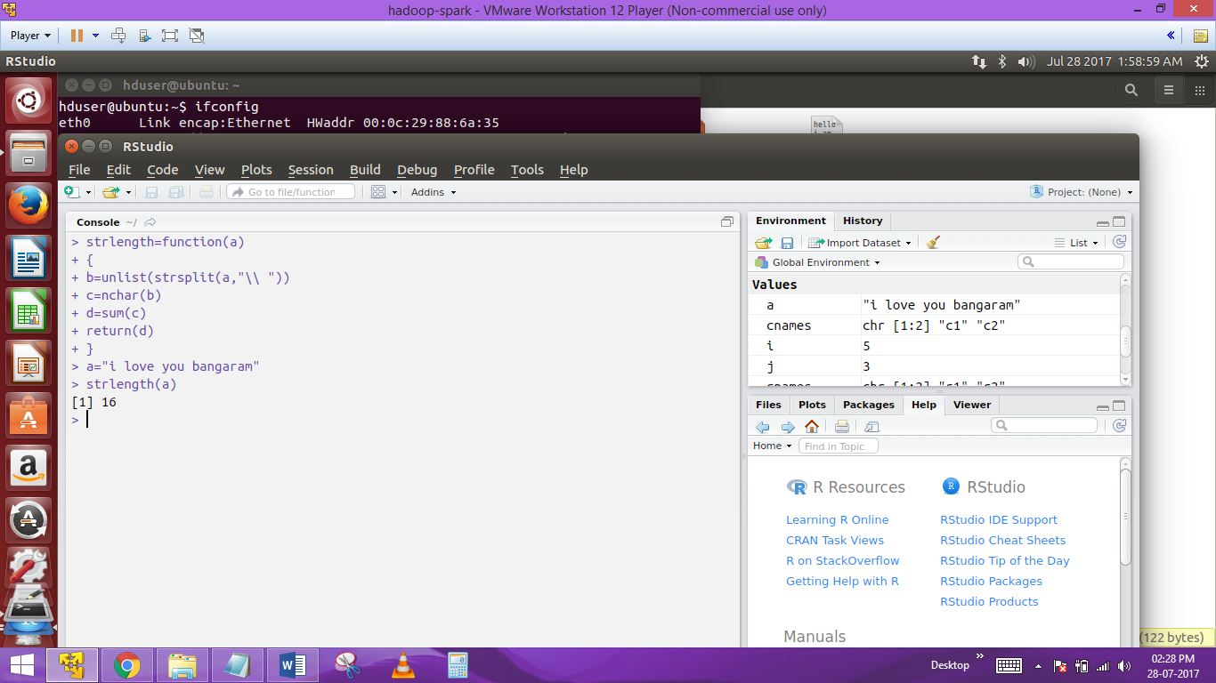

> strlength=function(a)

+ {

+ b=unlist(strsplit(a,"\\ "))

+ c=nchar(b)

+ d=sum(c)

+ return(d)

+ }

> a="i love you bangaram"

> strlength(a)

[1] 16

13) A program which contains a function which takes a string as an argument and returns the total numer of spaces in that string

A=””how are you”

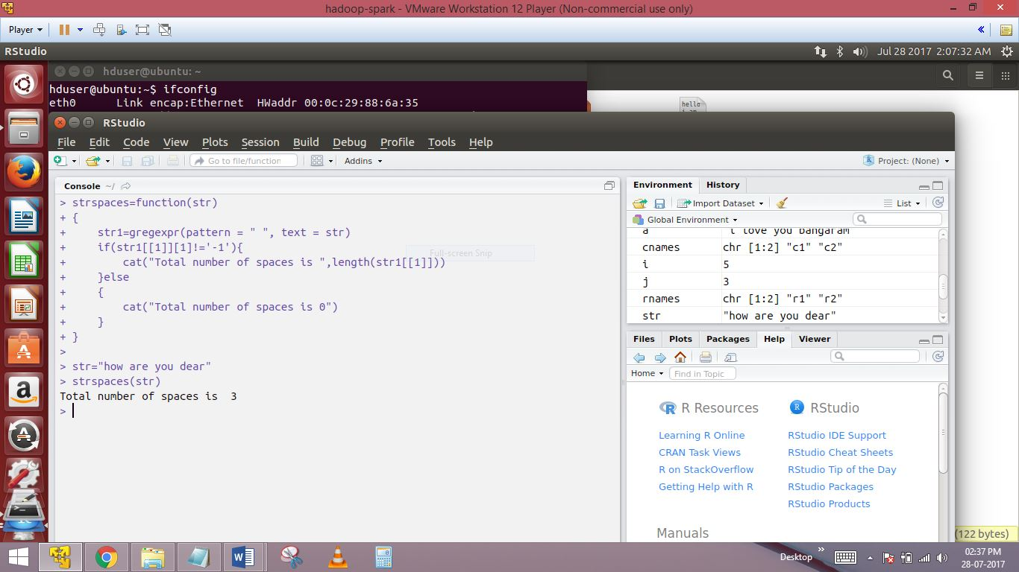

Total num of spaces is 3,this function should accept the string as an argument and return the number of white spaces in the input string ,the output would be 3..

14) A program to demonstrate a function calling another function

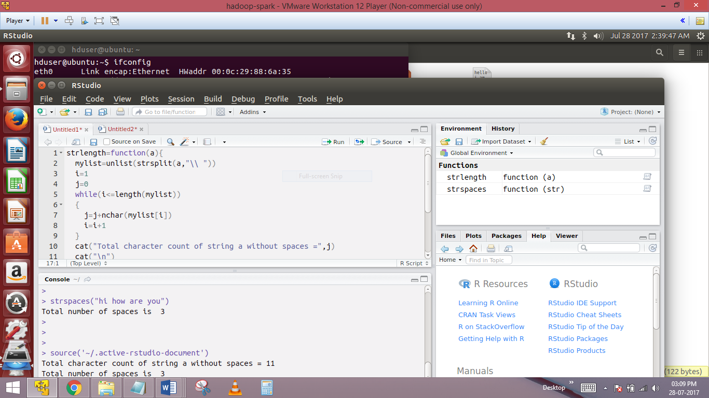

strlength=function(a){

mylist=unlist(strsplit(a,"\\ "))

i=1

j=0

while(i<=length(mylist))

{

j=j+nchar(mylist[i])

i=i+1

}

cat("Total character count of string a without spaces =",j)

cat("\n")

strspaces(a)

}

OUTPUT:

> strspaces("hi how are you")

Total number of spaces is 3

>

>

>

> source('~/.active-rstudio-document')

Total character count of string a without spaces = 11

Total number of spaces is 3

-------------------------------------Data frames--------------------------------------

15)Data Frames

Data frame : when we import a csv file into into R,it gets stored as a data frame. Basically dataframes can be seen a collection of vectors arranged in rows & columns

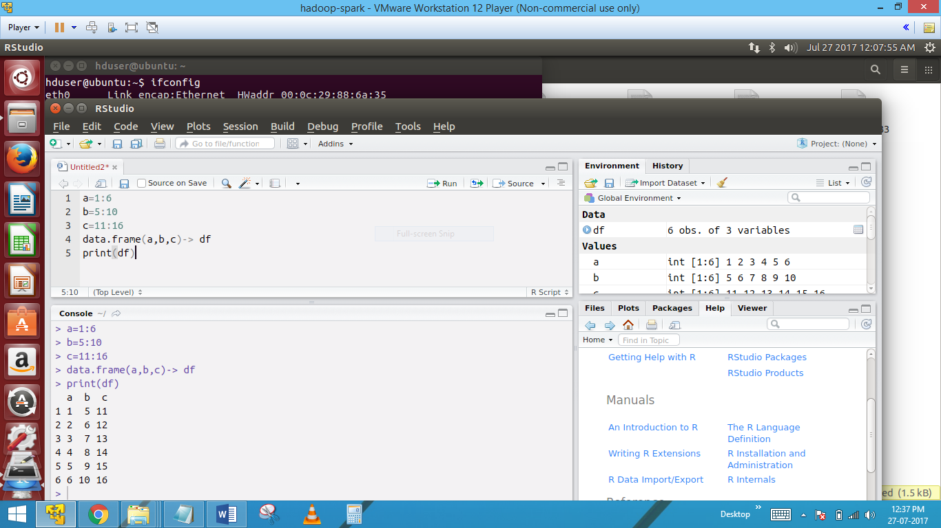

How to create a data frame without using a csv file..

We have to manually load the data into individual vectors and then pass them as argument to the data.frame function

16)Structure of data frame

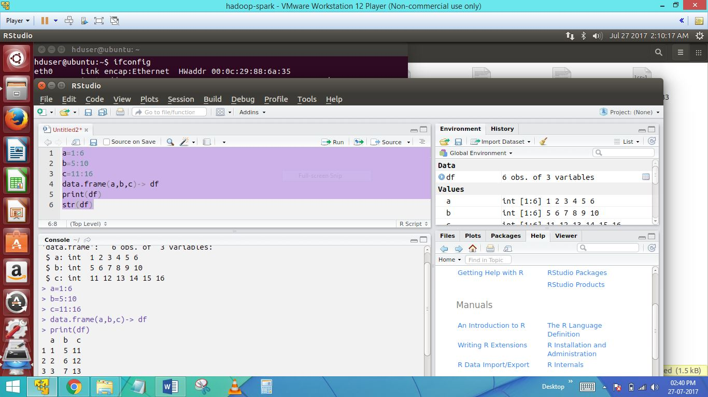

Here str command allows you to check the structure of data frame..

17)summary(df)

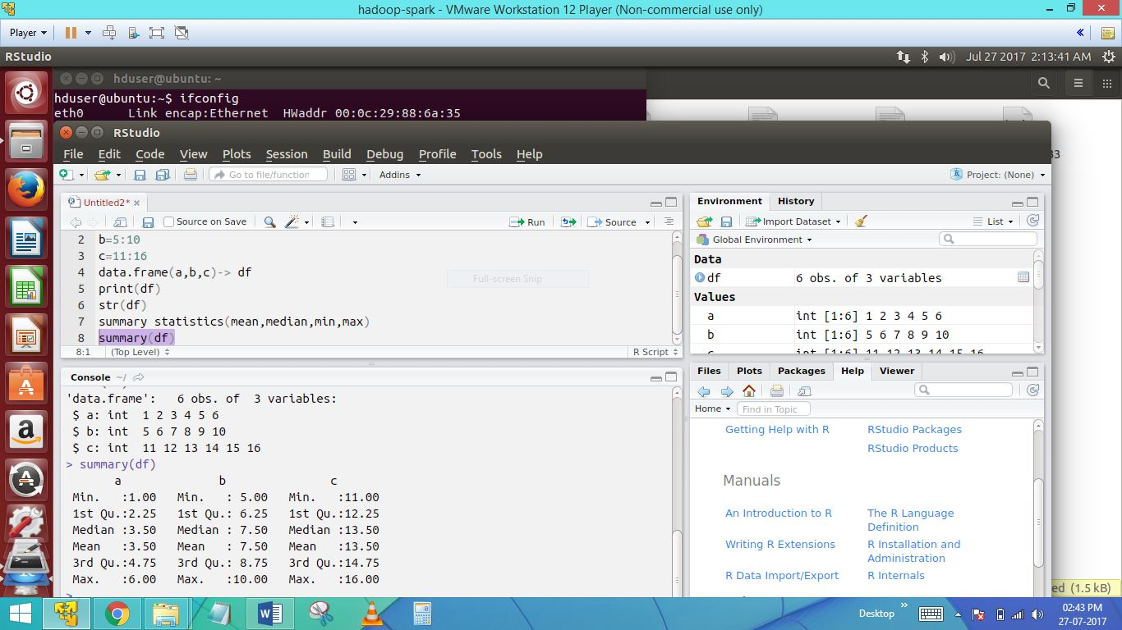

The summary function in data frames to provide the summary of the data

18)df$a

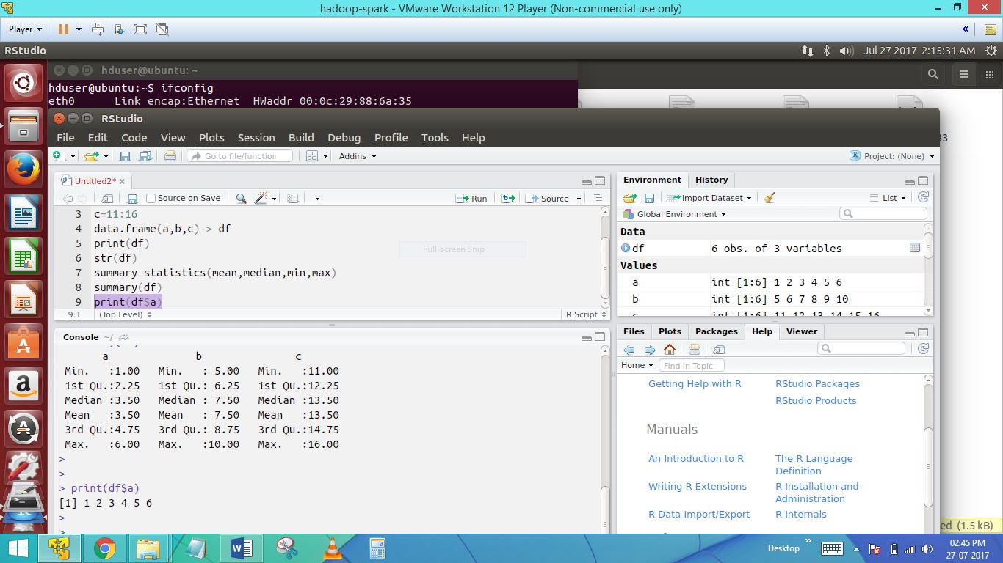

Accessign the data from the data frame was created (df) is composed of 3 vectors(a,b,c) which aare 3 columns of the data frame

Print(df$a)

19)row1=df[1]

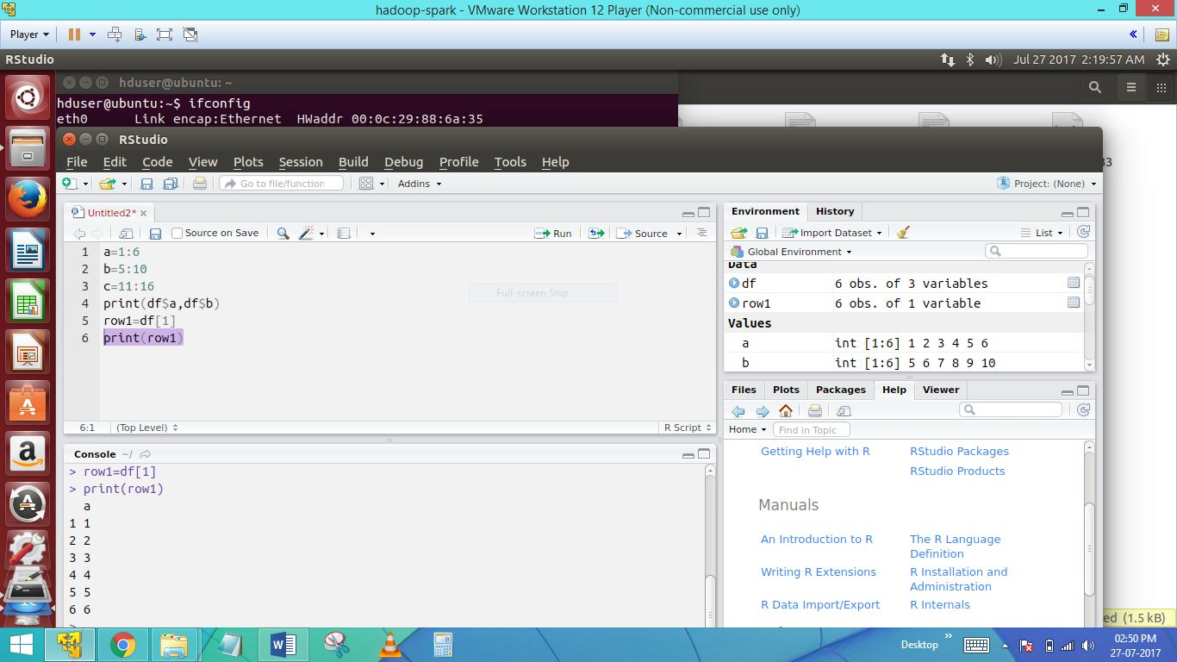

The above is to exact the exact the first row from the data frame..

20)row1t02

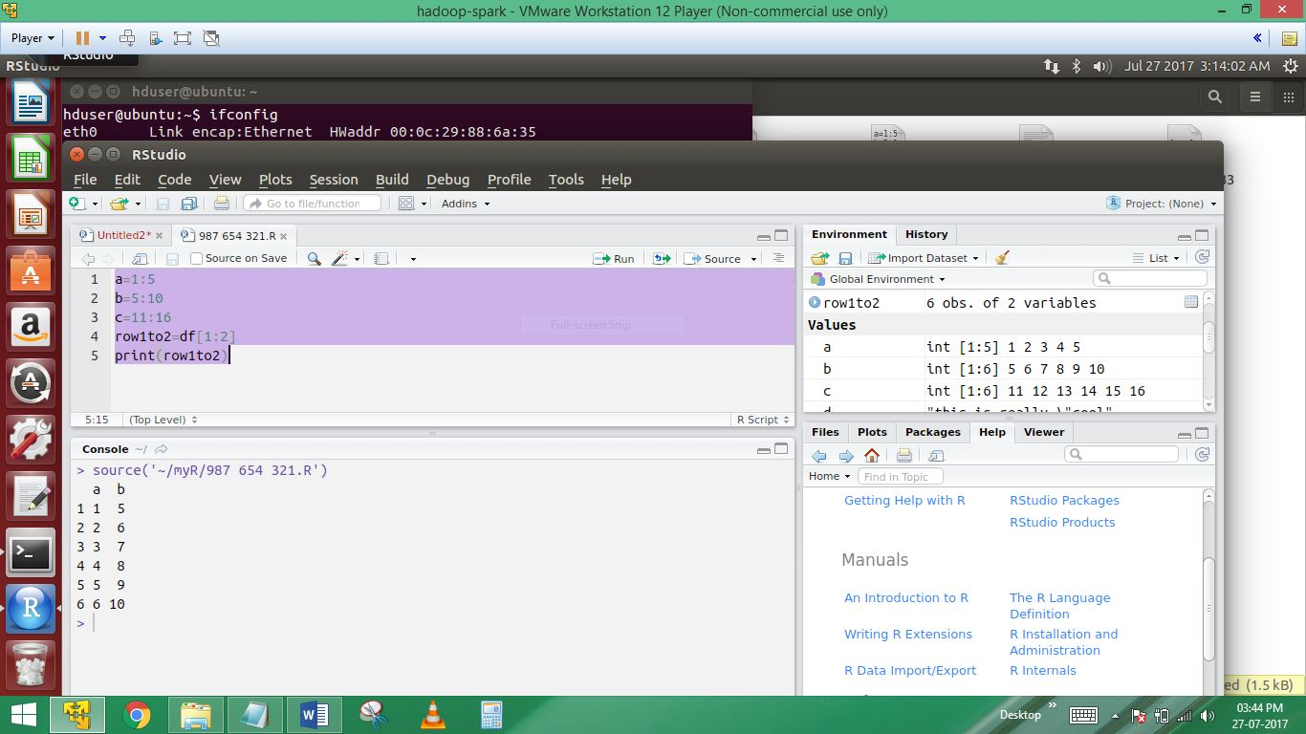

The above statement is to extract the first 2 rows from the data frame..

21)row15&column13

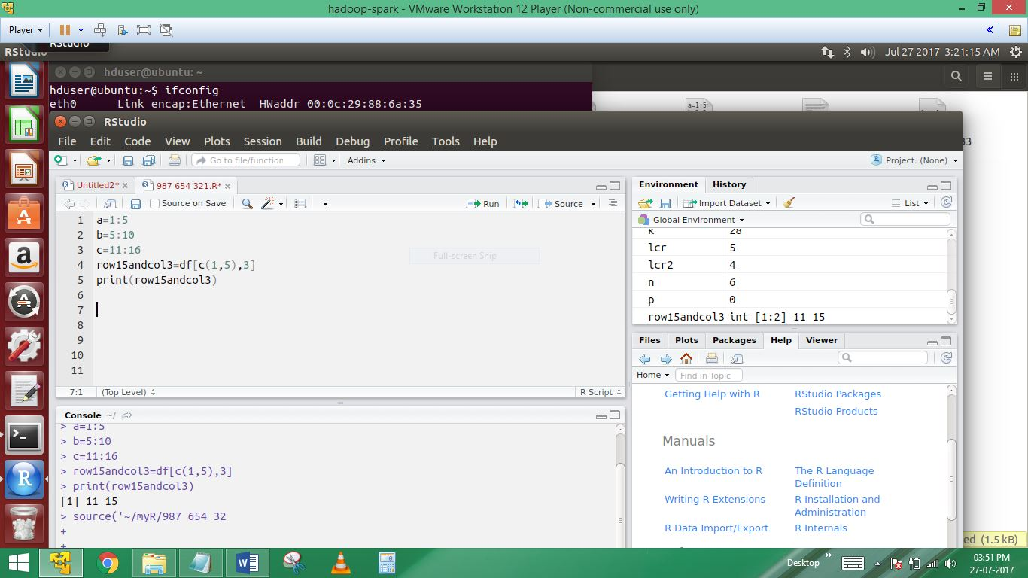

Only the 3rd column elements of row 1 and 5

22)Adding more rows and columns to a data frame

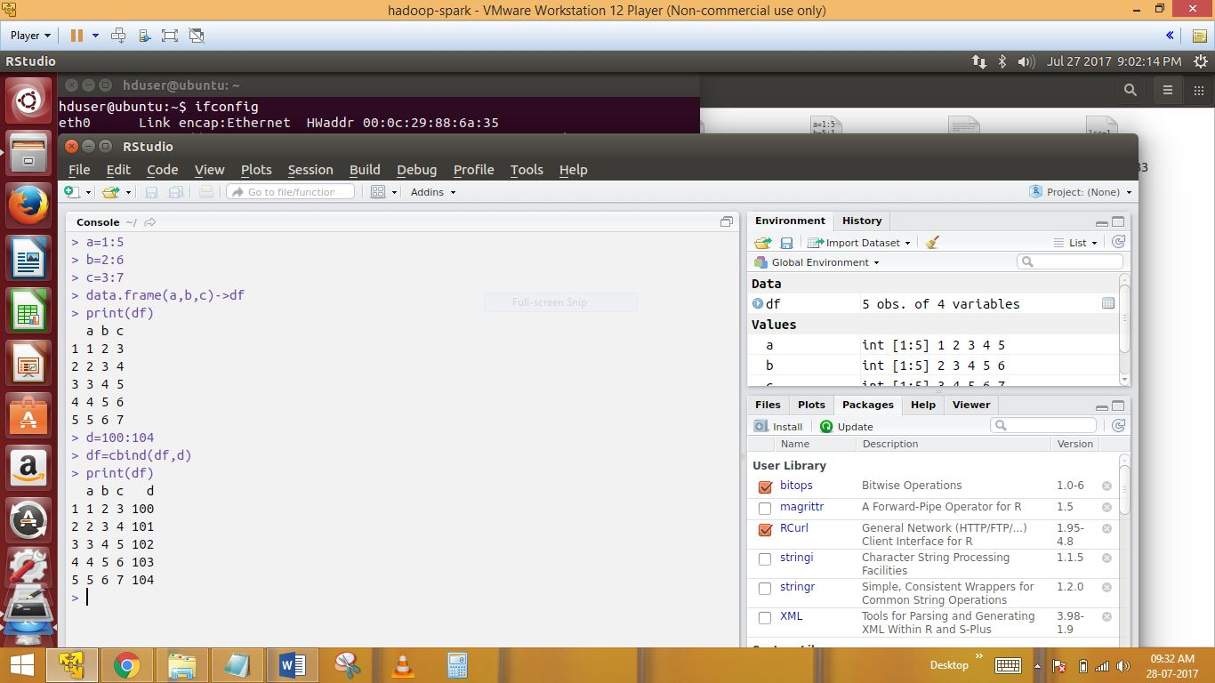

Here extra adding d vector to the df using CBIND command

23)rbind

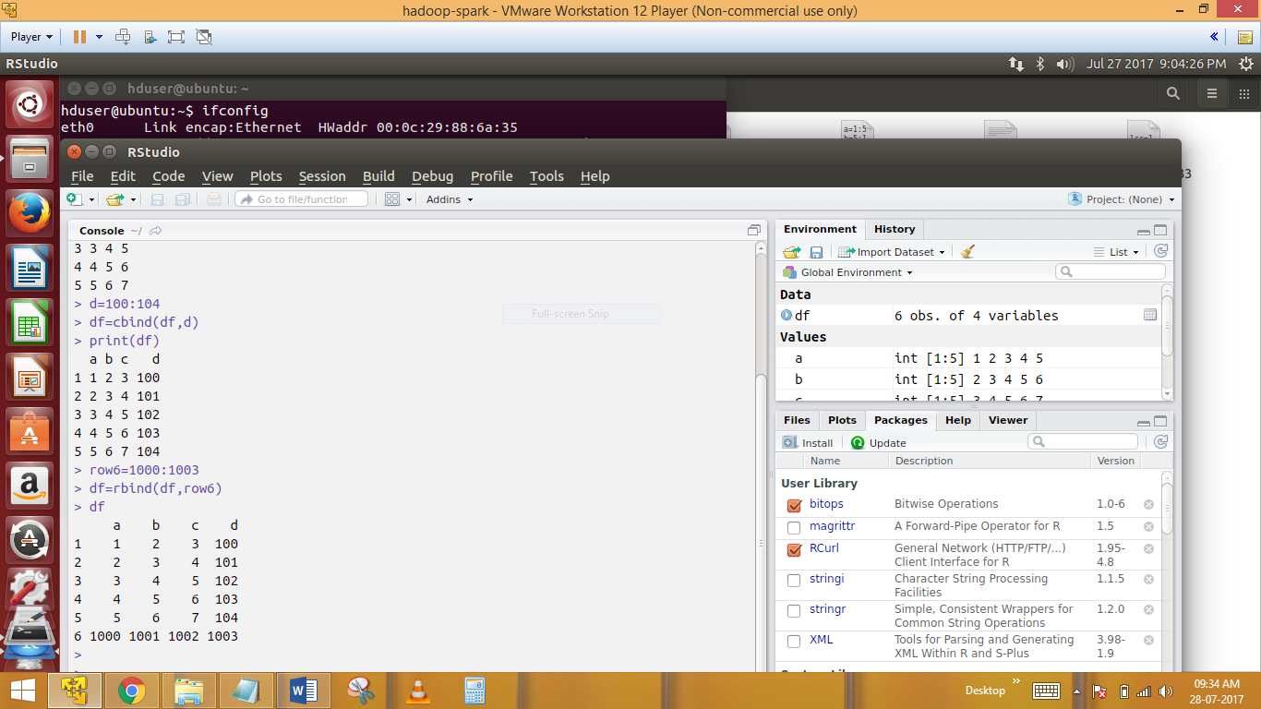

24)fix(df)

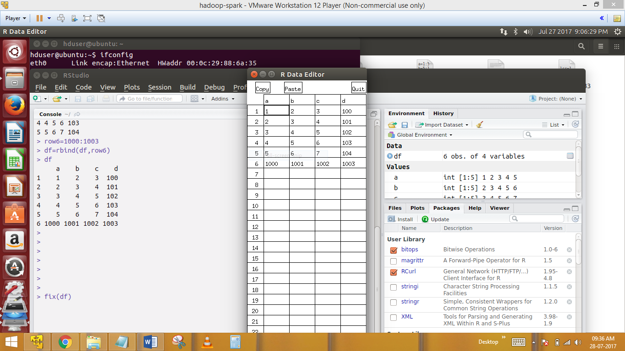

Very large data frame which does not fit into the R console

25)interchange

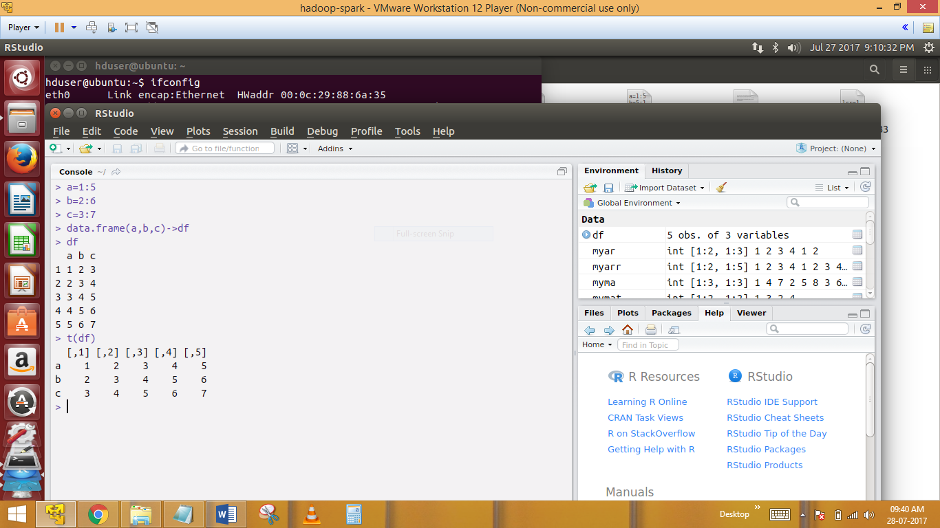

Function is used to obtain the transpose of a data frame

Syntax: t(df)

26)

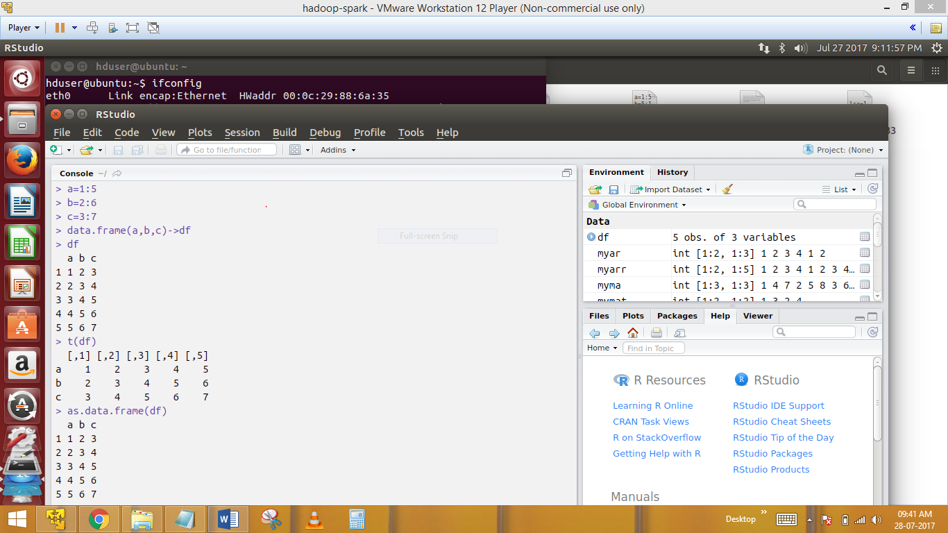

We need to use as.dataframe (df) to convert it back to data frame

------------------More on data access from data frames-----------------

27)Head(df)



Suppose we have a data frame with 6 rows using the head command we can see just the first 6 rows of the data frame

Head(df)

28)head(df,1)

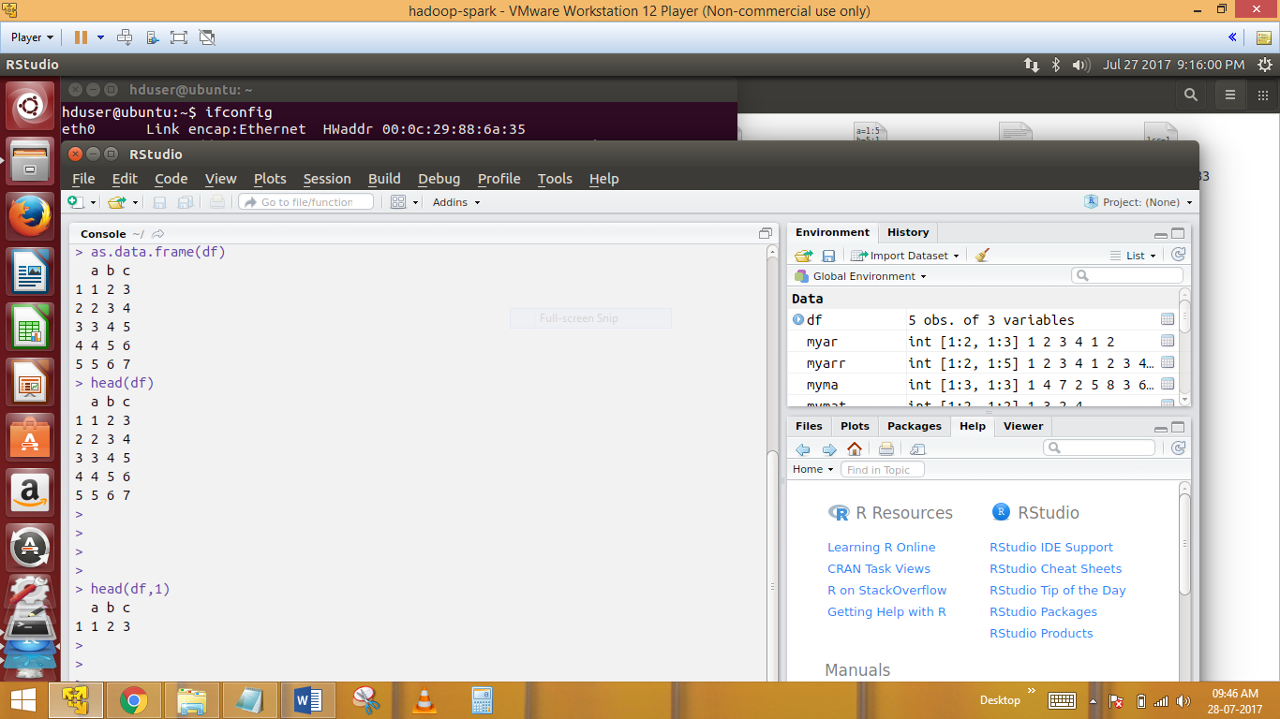

Head(df,1)will display first 20 rows of the data frame ,where bdf is the name of the data frame

29)tail(df)

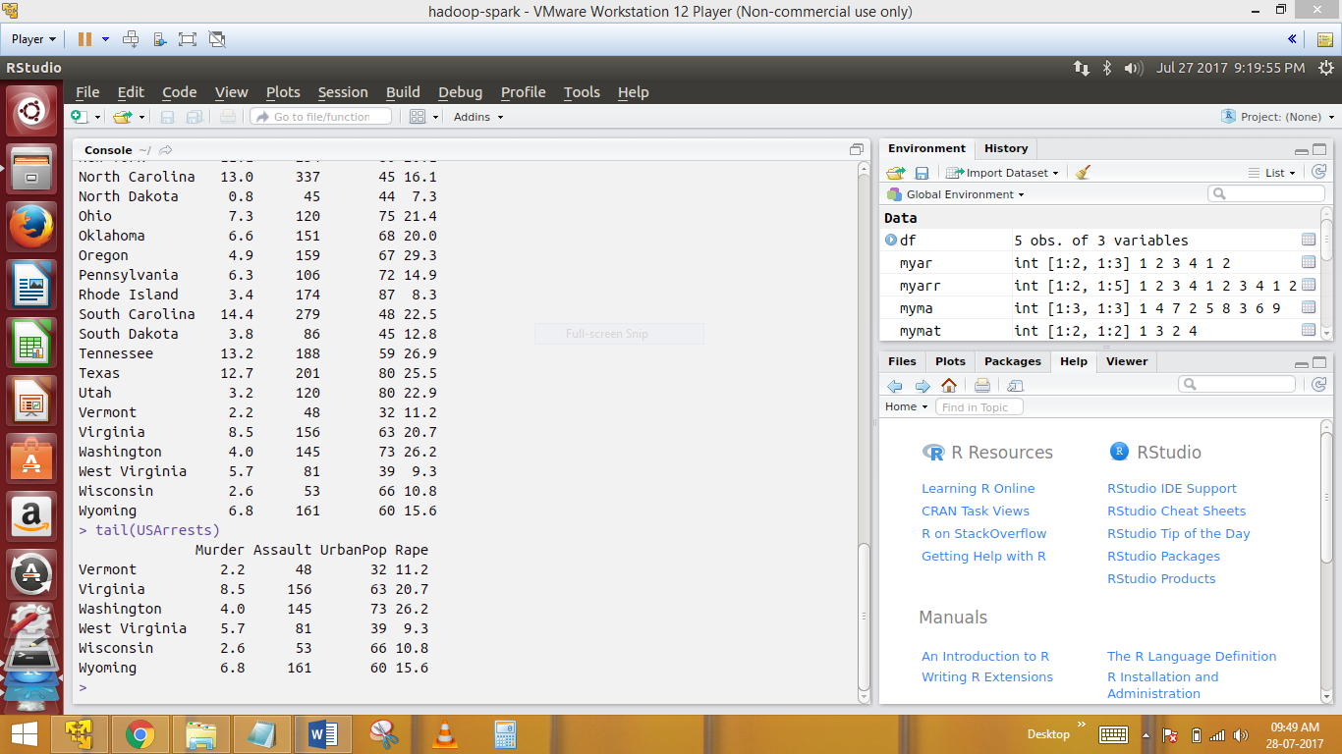

View last 6 rows of data frame

30)na.omit

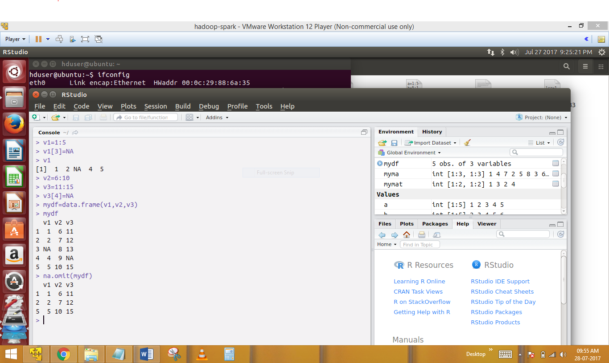

The entire row which contains NA will be ignored..

31)bdf[which(df[,1]>1),1]

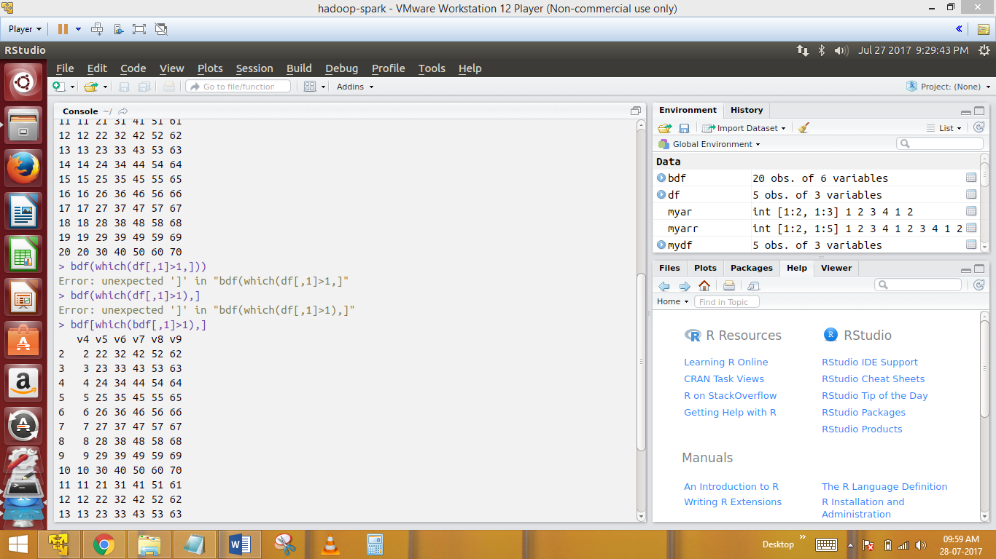

Suppose I have a dataframe with 20 rows and 6 rows columns and I want all the elements from all the rows of but just first column which is greaterthan 1

32) bdf[which(bdf[,1]>1&bdf[,2]>22),]

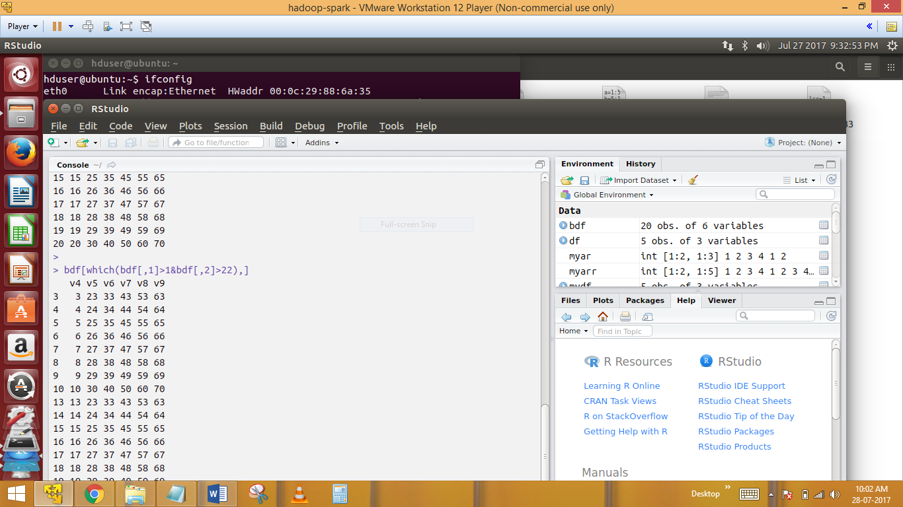

The second condition after the & operation means I need the rows of second column which is lessthan 22 ,now both conditions in the which function must be met in order to produe the output

33) bdf[which(bdf[,1]>7),1]

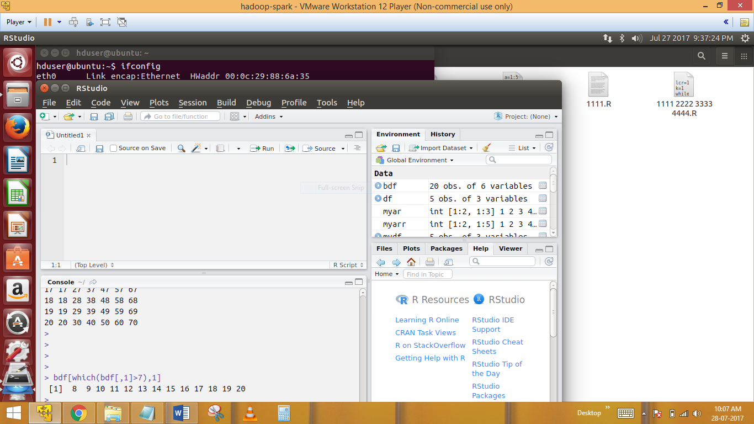

All the numbers greather than 4 in the first colun for all rows

34) which(bdf[,1]>4)

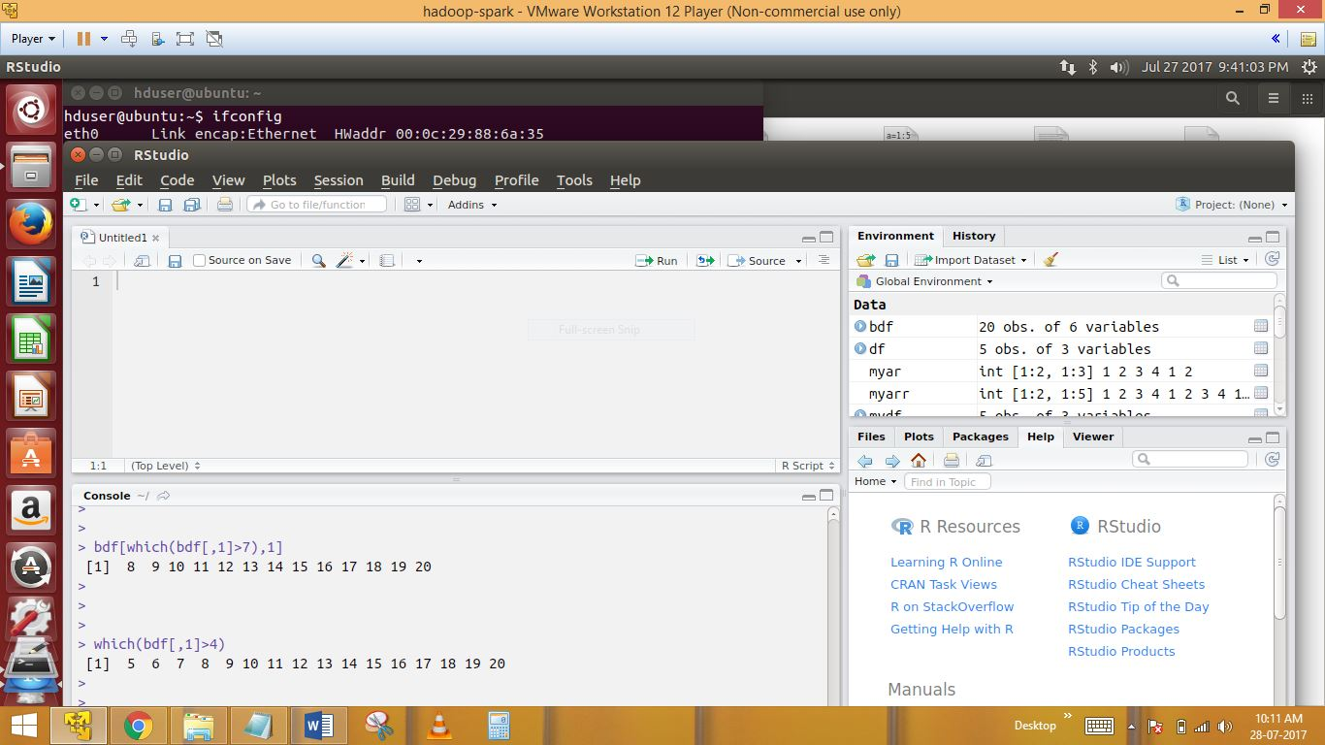

Which bdf[,1]>4 will to fetch all rows from first column

------------------------------------------some more functions on vectors----------------------------------------

35)

A=1:10

Range(a)

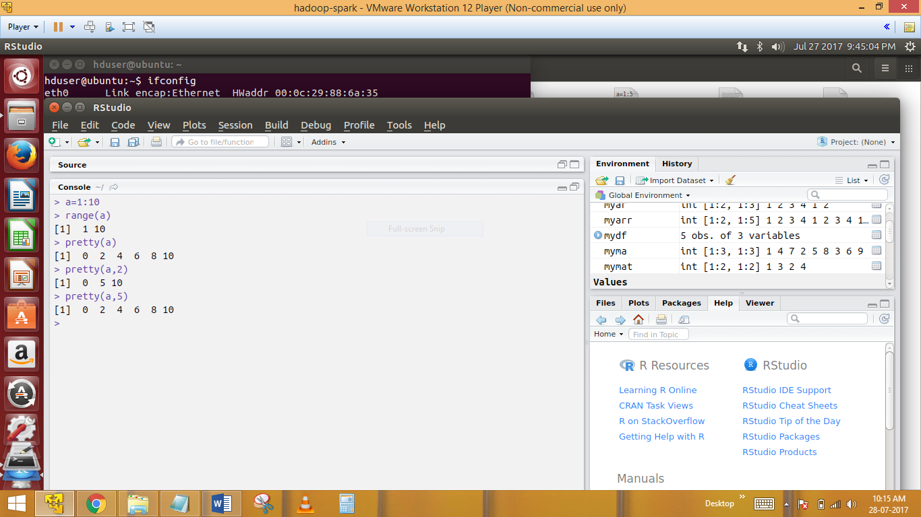

The highest and the lowest values in the vectors v

Pretty function a

& pretty(a,5)

In above function.

Pretty(a) produces a new vector containing the elements from the original vector ,with the specified inervels..

**----------------------------Factors-------------------------------------**

36)

What is factor?

A factor –type vector contains a et of numeric does with character valued levels

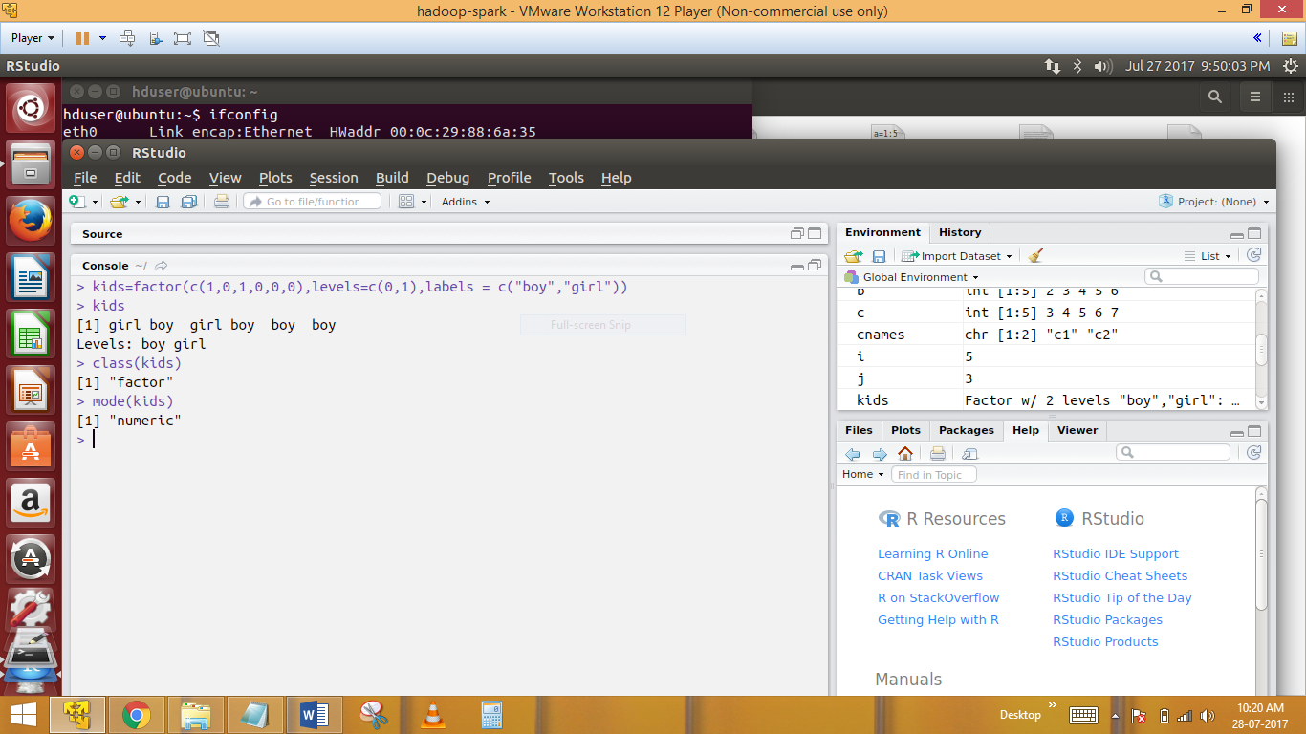

> kids=factor(c(1,0,1,0,0,0),levels=c(0,1),labels = c("boy","girl"))

> kids

[1] girl boy girl boy boy boy

Levels: boy girl

Here we find mode & class of the factor & assign names to the arguments..

37) f=factor(c("pig","hive","hbase","pig"))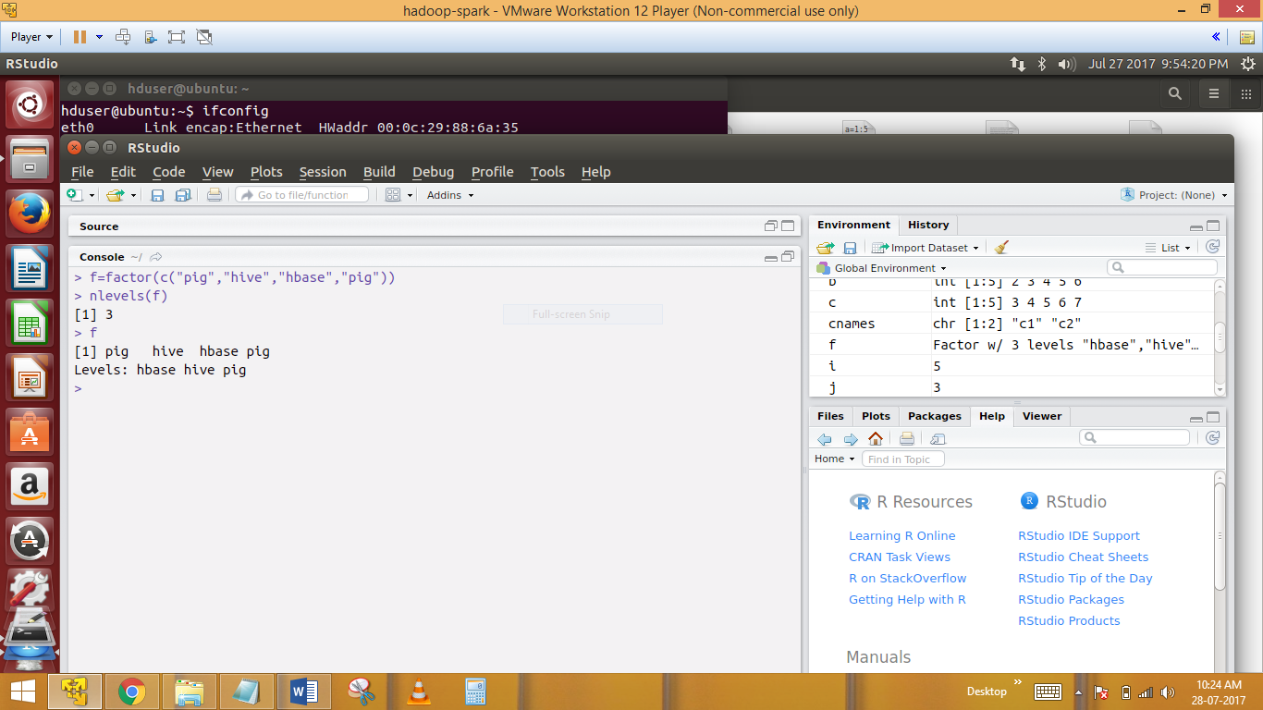

N levels would print the number of unique data in th above list

Output would be 3

38)Factor sizes

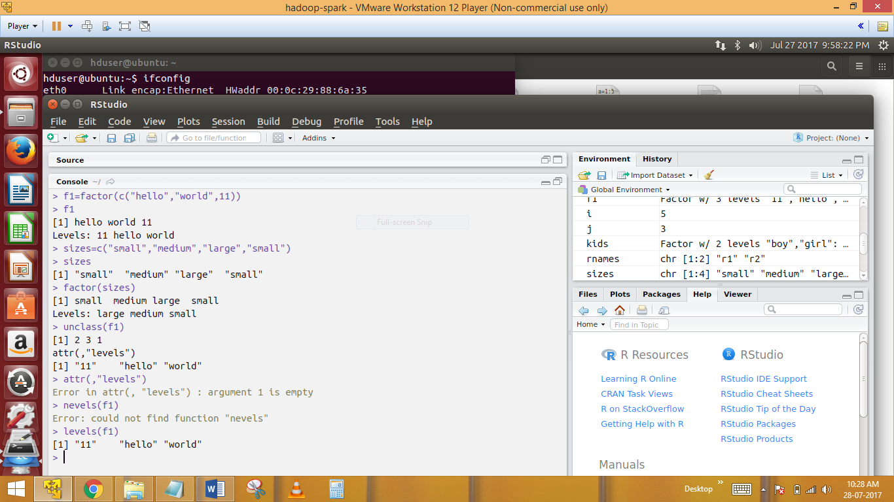

> f1=factor(c("hello","world",11))

> f1

[1] hello world 11

Levels: 11 hello world

> sizes=c("small","medium","large","small")

> sizes

[1] "small" "medium" "large" "small"

> factor(sizes)

[1] small medium large small

Levels: large medium small

> unclass(f1)

[1] 2 3 1

attr(,"levels")

[1] "11" "hello" "world"

> levels(f1)

[1] "11" "hello" "world"

Factors are used in ploy=tting graphs while working categorical data

> sizes=c("small","medium","large","small")

> sizes

**-----------------------------------------------SUBSETTING---------------------------------**

39)The subset function allows us to selectively pick the data from an R object

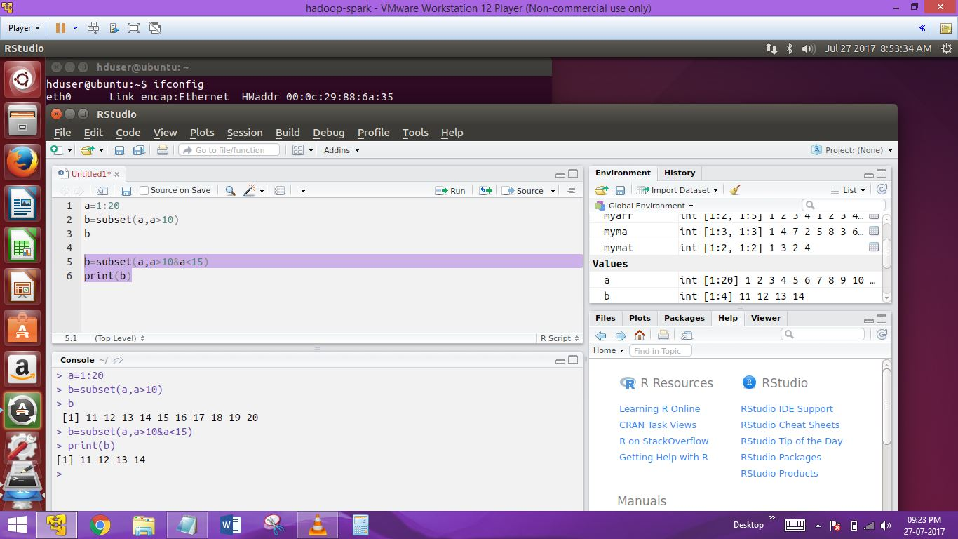

40)

WAP to pick only the elements from vectors which are divisible by 5 &7

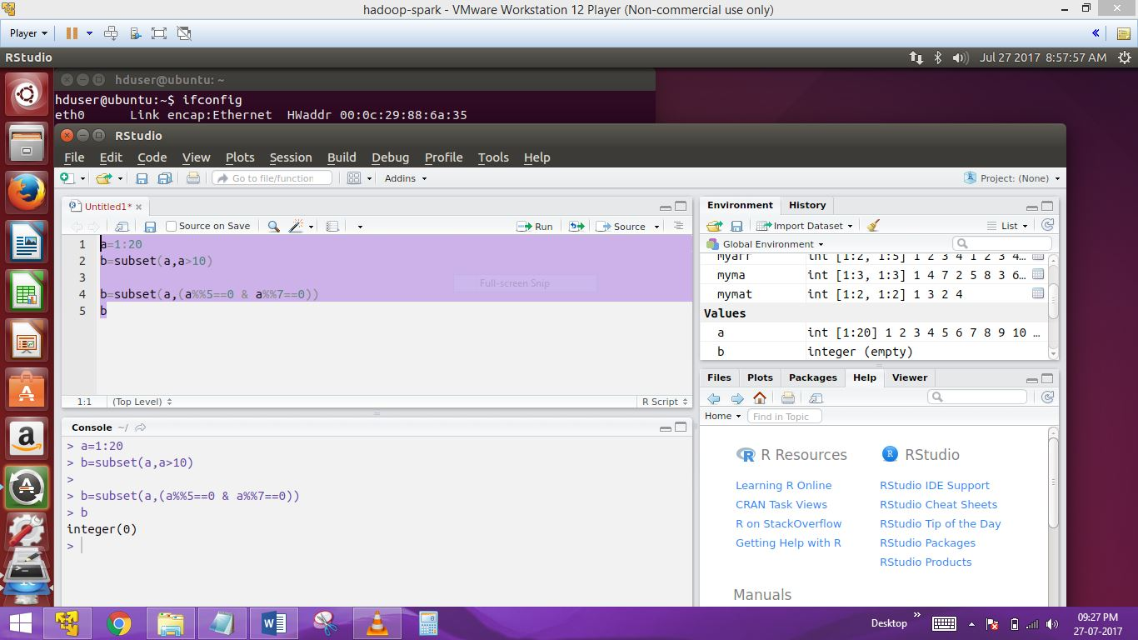

Here we using Subset function to assign b into 5 & 7 we get output integer(0)

41)USArrests

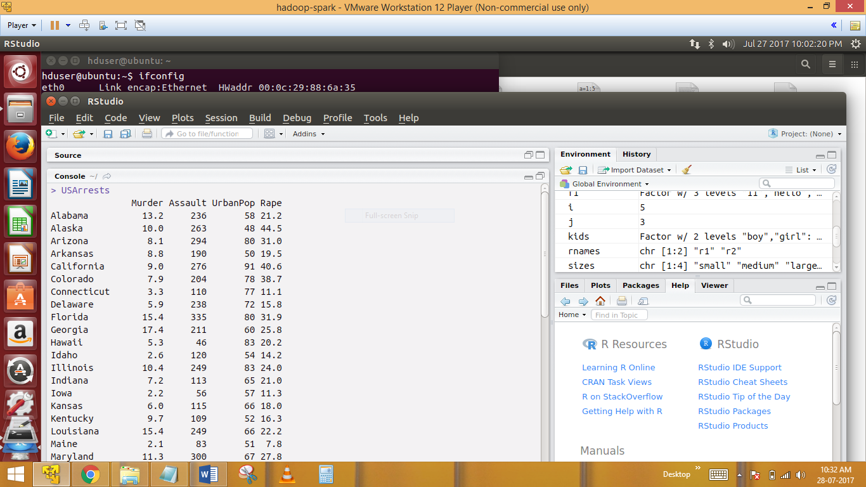

Its default USArrests in R DATA BASE

42)Lets pick up all the columns based on the condition that the population is greatherthan 70 millions

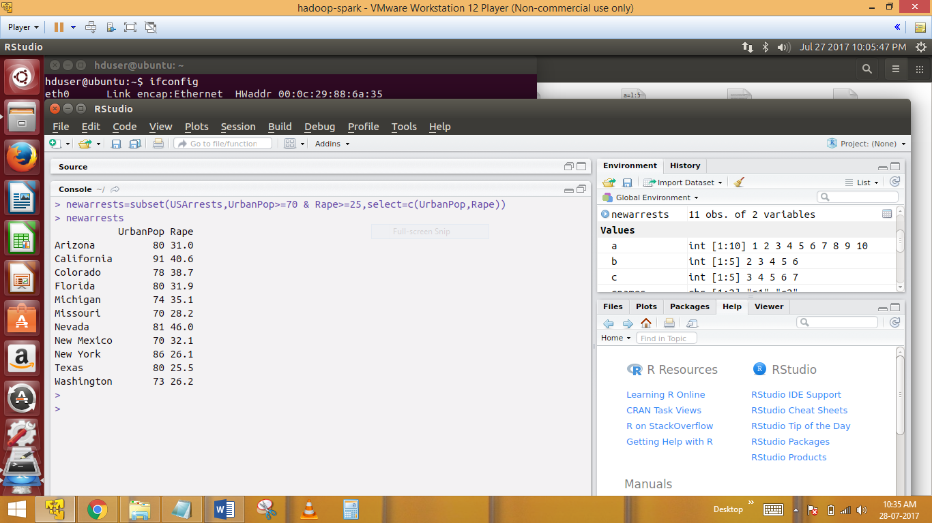

newarrests=subset(USArrests,UrbanPop>=70 & Rape>=25,select=c(UrbanPop,Rape))

print(newarrests)

42)Lets order the newarrests data frame by the population

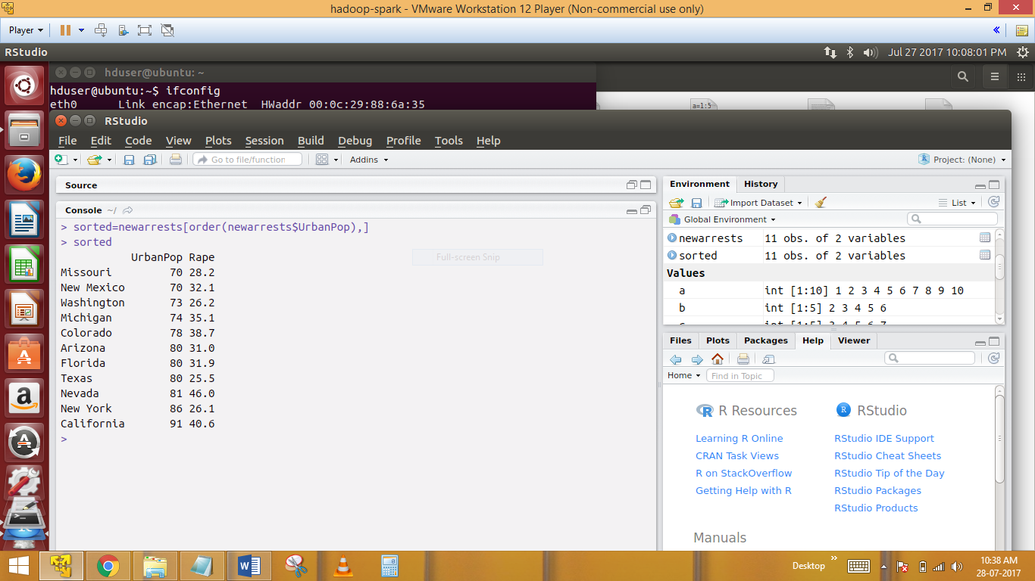

sorted=newarrests[order(newarrests$UrbanPop),]

sorted

43)

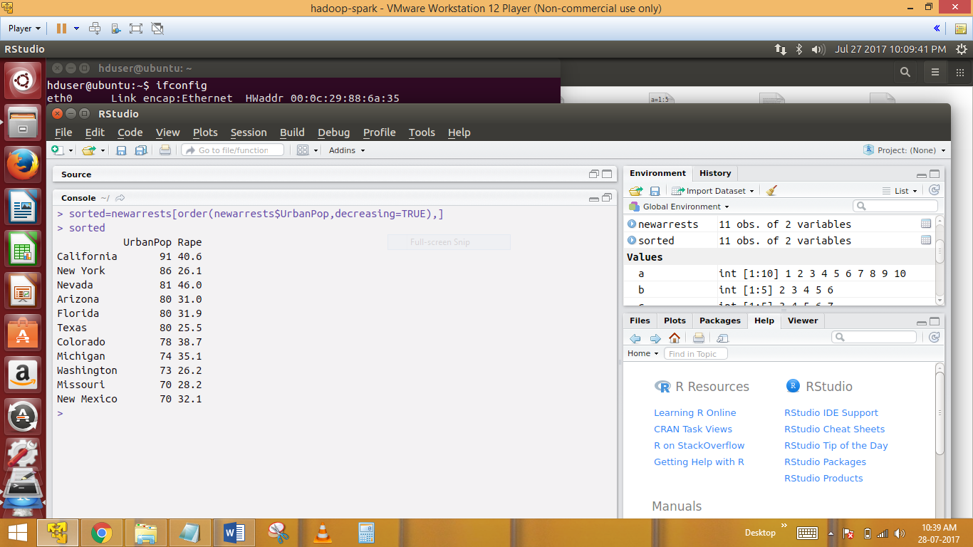

For decreasing ordering of the dataframe

sorted=newarrests[order(newarrests$UrbanPop,decreasing=TRUE),]

sorted after this decreasing the data from TRUE..

TABLES :

44)The structure of data in tables and data frames are the same however

Table is an extension of the data frame and has feature for speedy access of data and favours operations like joi ,in a better way than that of data frames

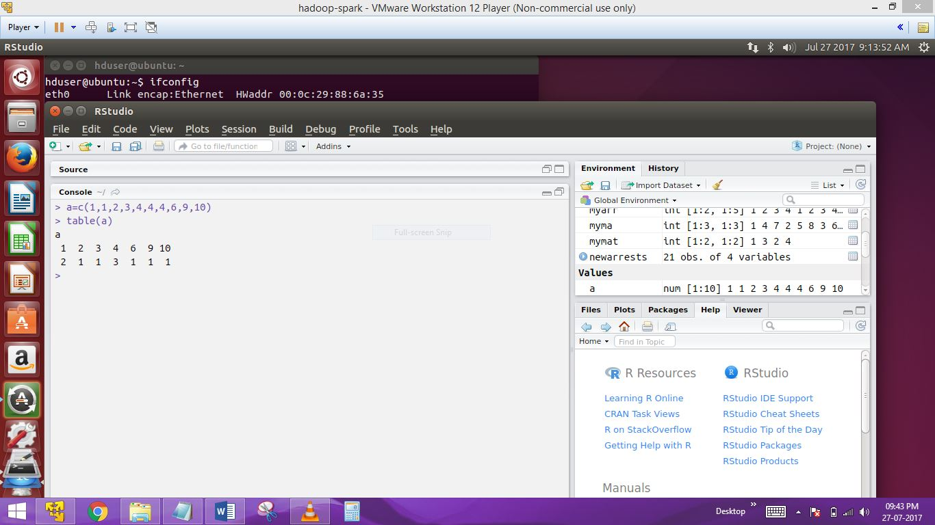

a=c(1,1,2,3,4,4,4,6,9,10)

table(a)

a

1 2 3 4 6 9 10

2 1 1 3 1 1 1

45)table(USArrests,[3]

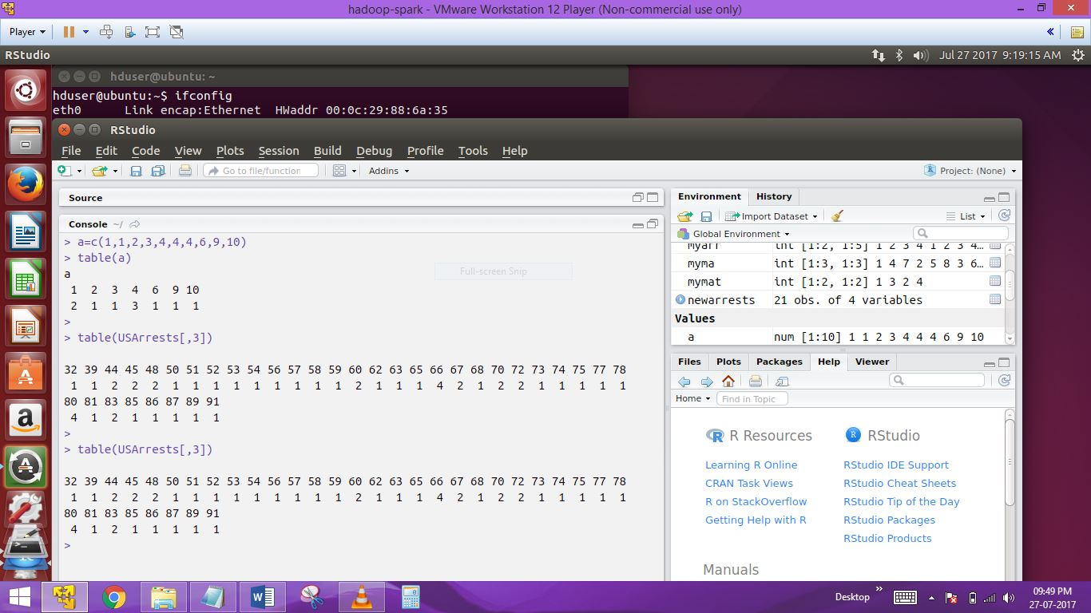

46)creating a table from matrix

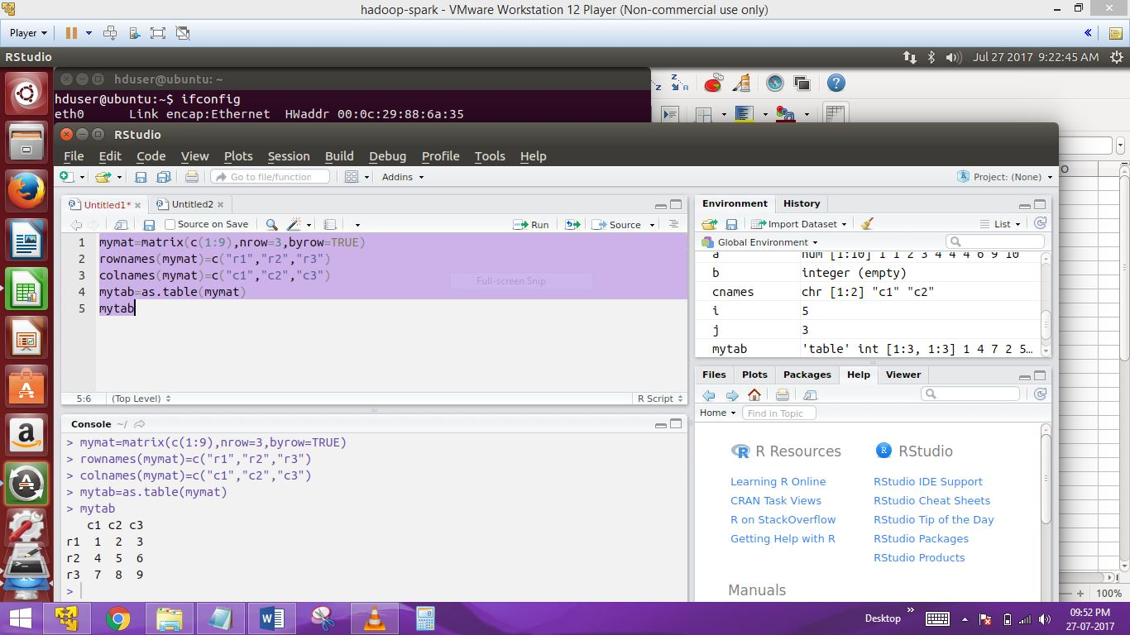

> mymat=matrix(c(1:9),nrow=3,byrow=TRUE)

> rownames(mymat)=c("r1","r2","r3")

> colnames(mymat)=c("c1","c2","c3")

> mytab=as.table(mymat)

> mytab

c1 c2 c3

r1 1 2 3

r2 4 5 6

r3 7 8 9

47)what is the difference b/w matrix and a data frame

Data frme is made of a collection of vectors which can contain different type of data objects where as a matrix would contain the same type of data

Table(USArrests[,3],USArrests[,4]

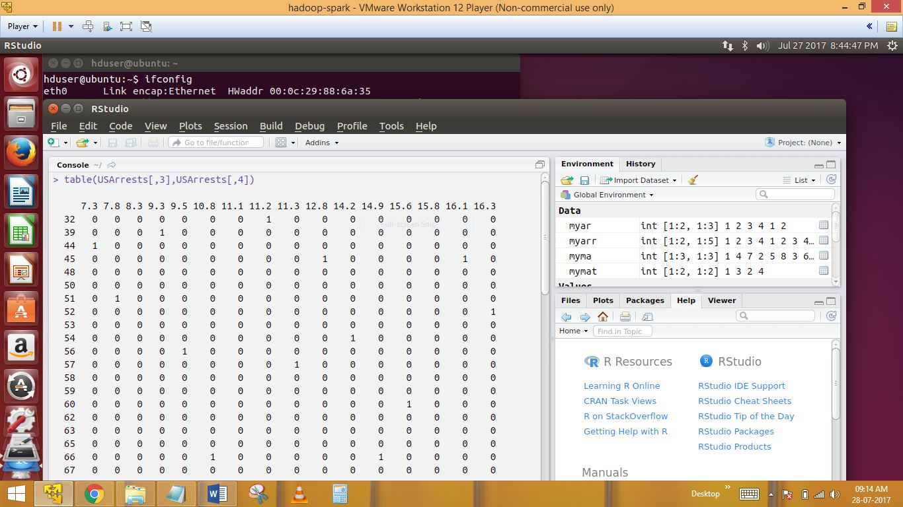

Data frme is made of a collection of vectors which can contain different type of data objects where as a matrix would contain the same type of data

48) table(airquality[,4],airquality[,5])

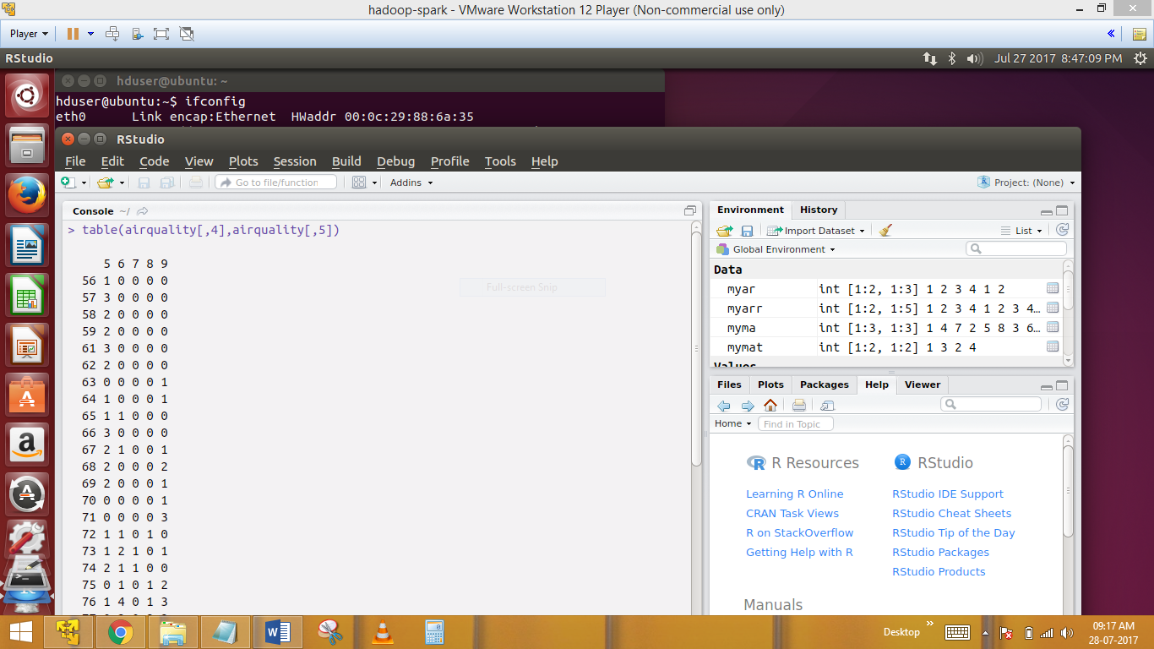

49)Browsing packages

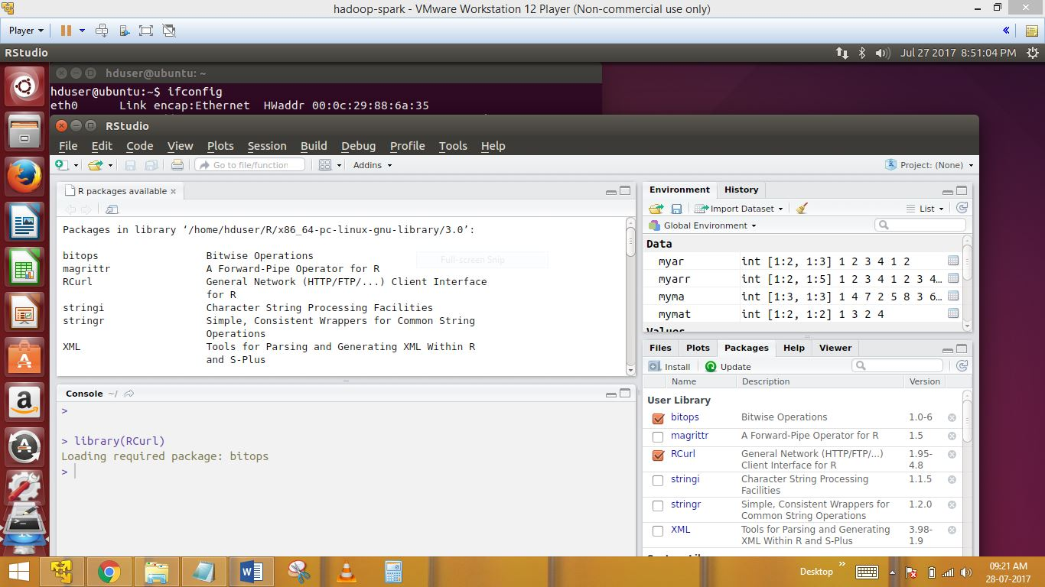library()

**FILE IO Operations:**

50)a=read.csv("/home/hduser/nik/nk.csv")

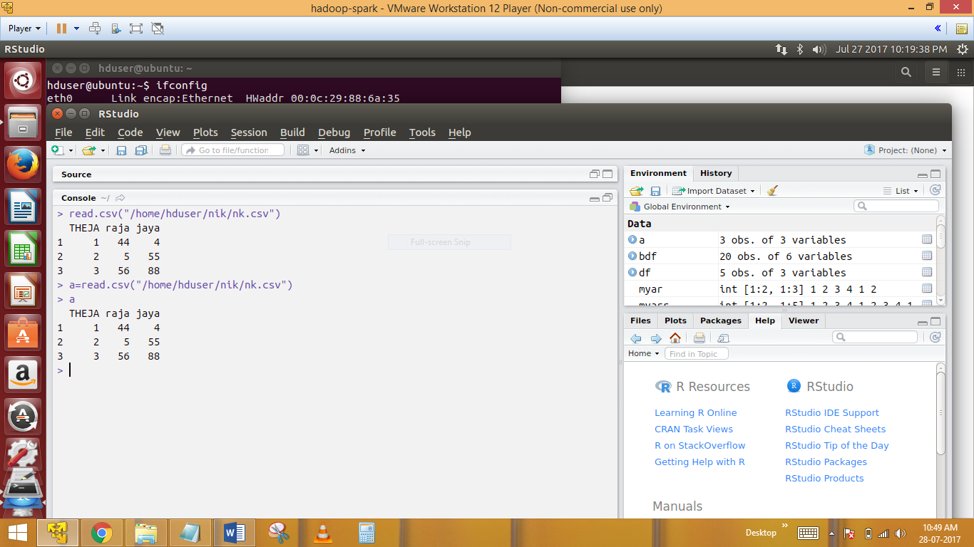

read.csv("/home/hduser/nik/nk.csv")

it will be a data frame and the first row the file will be missing..

51) > a=read.csv("/home/hduser/nik/nk.csv",header=F,stringsAsFactors = FALSE)

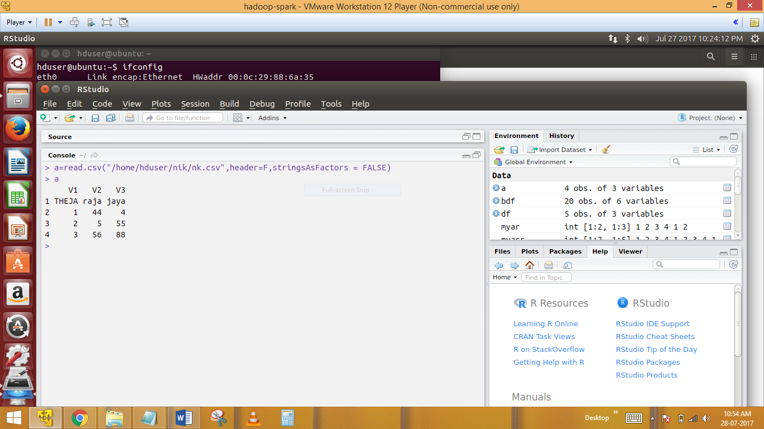

52)writing an object data in R into a fie

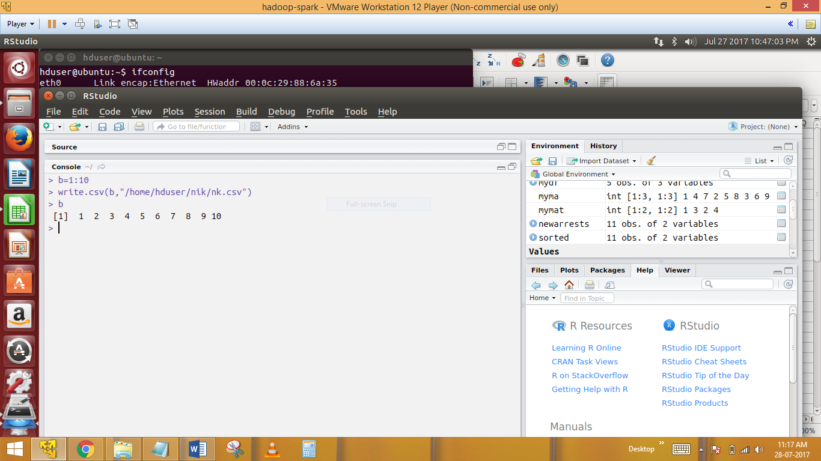

> b=1:10

> write.csv(b,"/home/hduser/nik/nk.csv")

53) write.csv(a,"/home/hduser/nik/nk.csv",row.names = F)

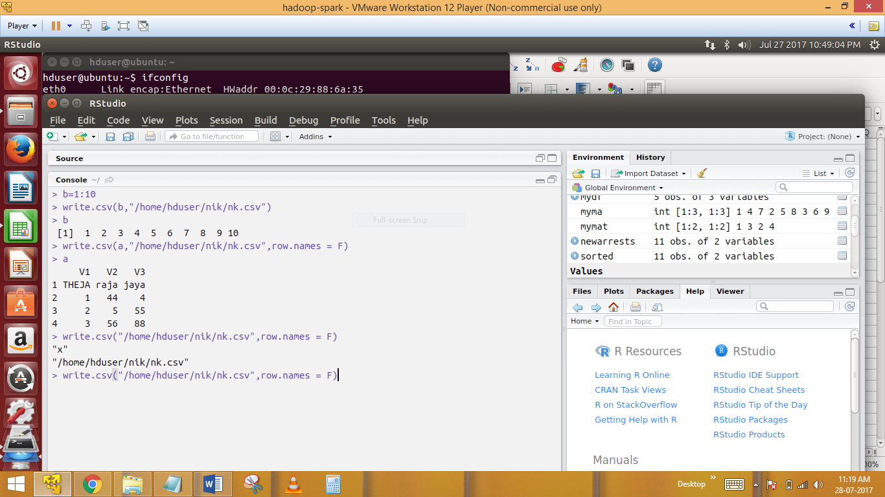

**----------------------------------There is workaround for doing thsis-----------------------**

54)Write table is a workaround for doing this

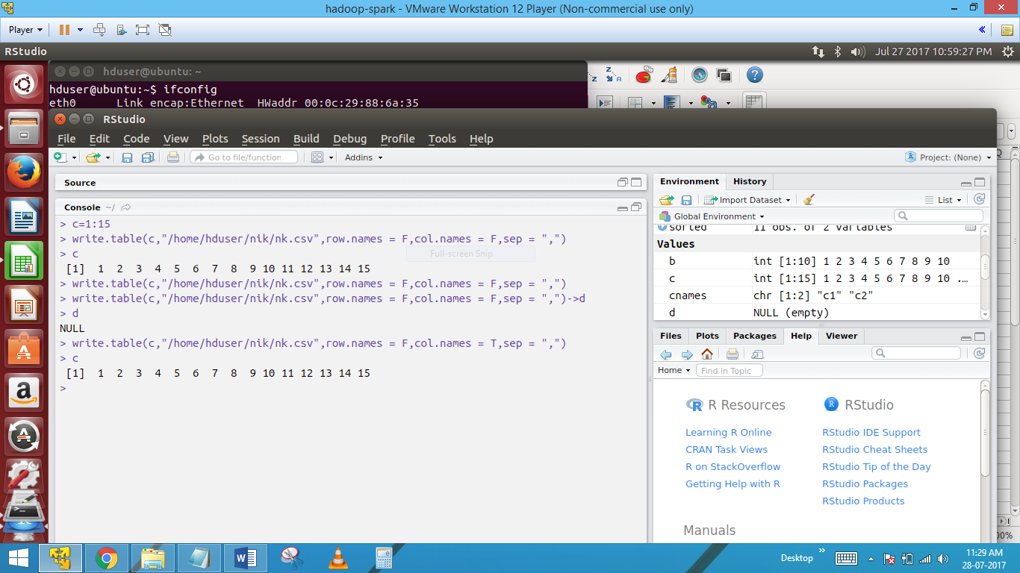

write.table(a,"write.csv",row.names=FALSE,col.names=FALSE,sep=",")

write A table in what we are giving the path in command as,,

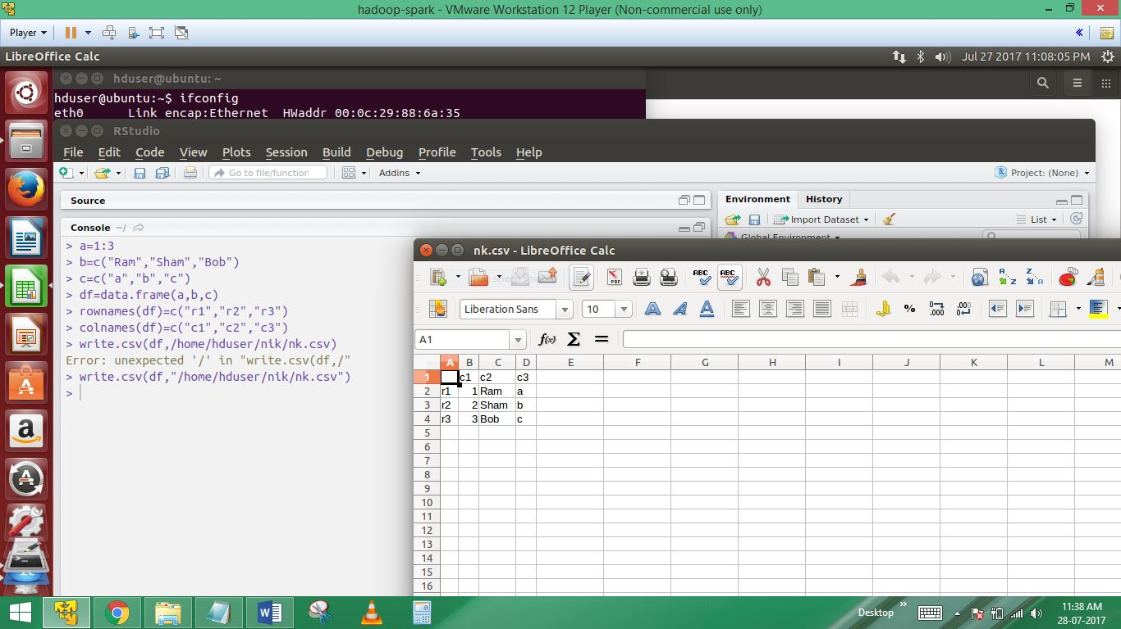

a=1:3

> b=c("Ram","Sham","Bob")

> c=c("a","b","c")

> df=data.frame(a,b,c)

> rownames(df)=c("r1","r2","r3")

> colnames(df)=c("c1","c2","c3")

> write.csv(df,/home/hduser/nik/nk.csv)

Error: unexpected '/' in "write.csv(df,/"

> write.csv(df,"/home/hduser/nik/nk.csv")

--------------------------------Something intresting------------------

56)Ignoring some lines from a CSV file while importing it

Note : there is no direct way but this is a workaround and can be quite

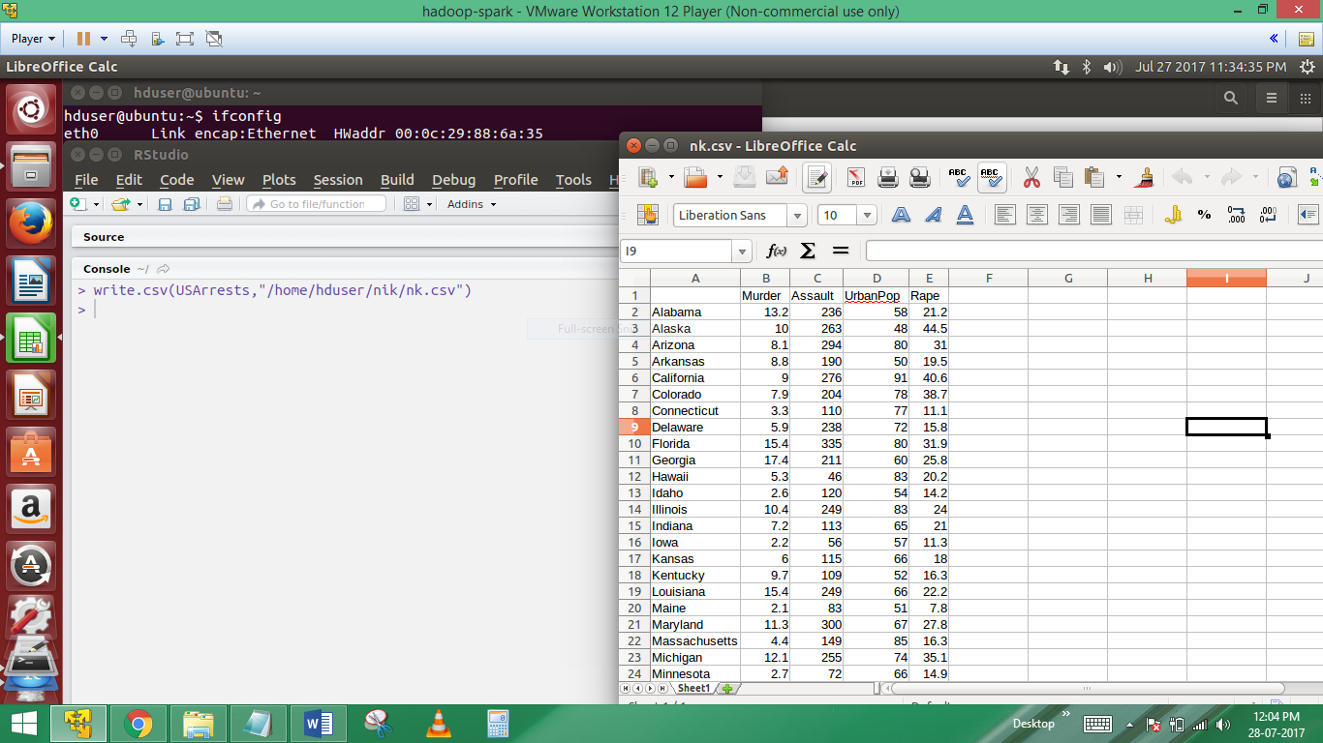

write.csv(USArrests,"/home/hduser/nik/nk.csv")

57) header=read.csv("/home/hduser/nik/nk.csv",skip = 1,header = F,nrows = 1,as.is = T)

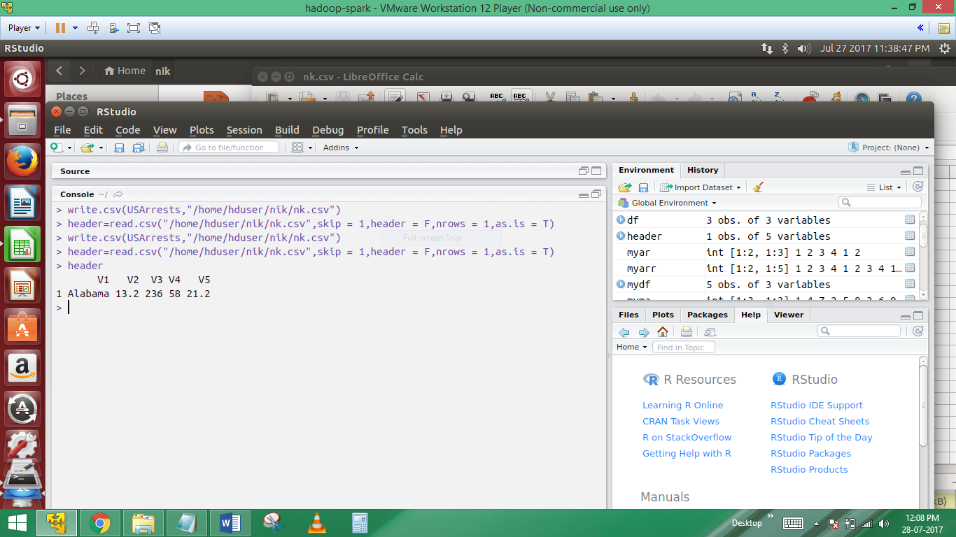

Here read only the header from a csv file

58) > mydf=read.csv("/home/hduser/nik/nk.csv",skip = 3,header = F)

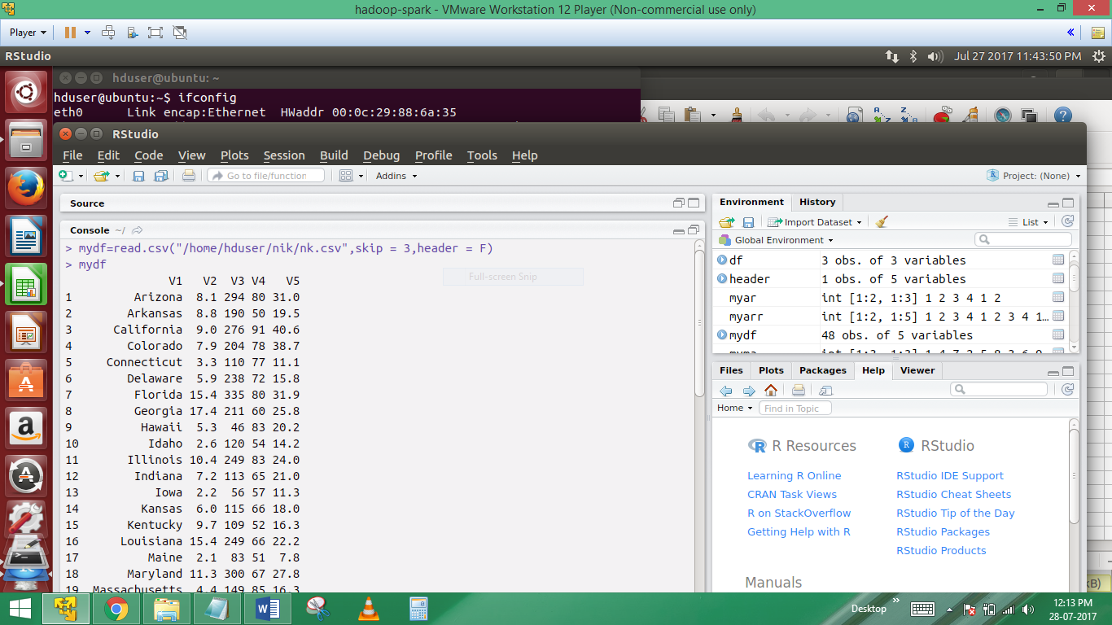

59)head(USArrests)

Head(mydf)

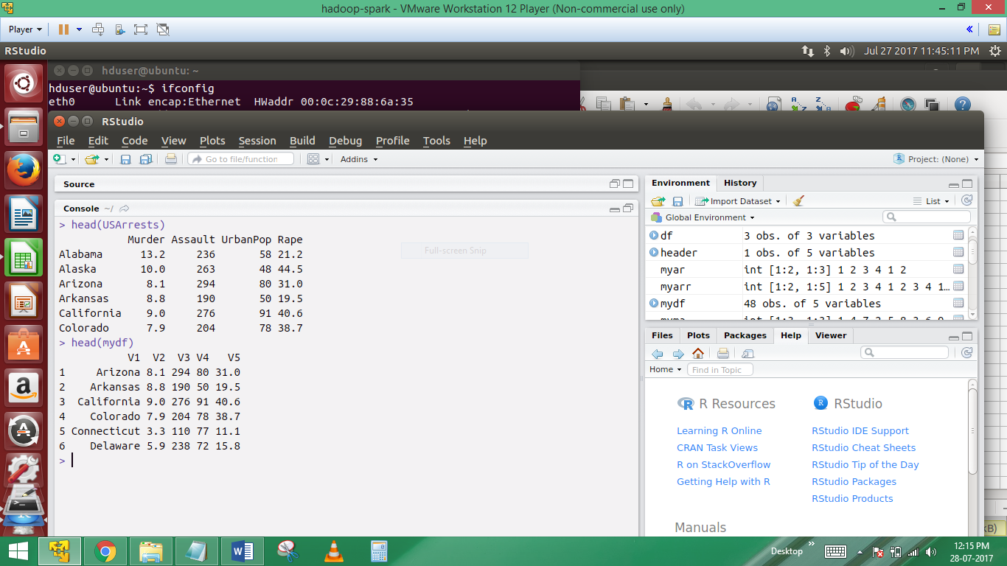

Head function prints only the first 6 lines from the data frame

---------------------------------------IMO+PORTING TEXT FILES-------------------------------------

60) Suppose I have a sample file like sample .txt which contains the below 2 lines of data

hello how are you

I am fine

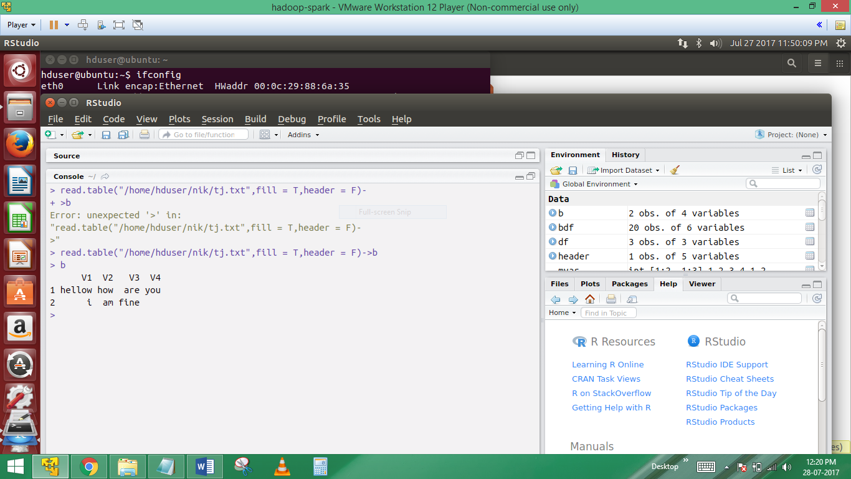

read.table("/home/hduser/nik/tj.txt",fill = T,header = F)->b

Now in the above input file,the fist line has 4 elements and second line has 3 elements fill = T will take care of this by filling blank spaces in the missing fields…

61)read.table(“pathname”,sep=”\t”)->c

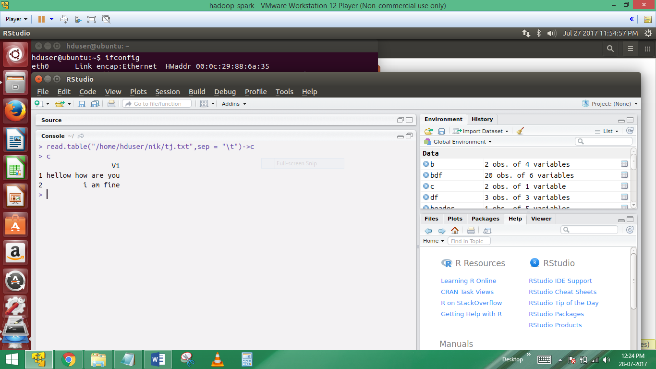

Here sep=”\t” means the input file is a TAB delimited file..

62)class of above function…

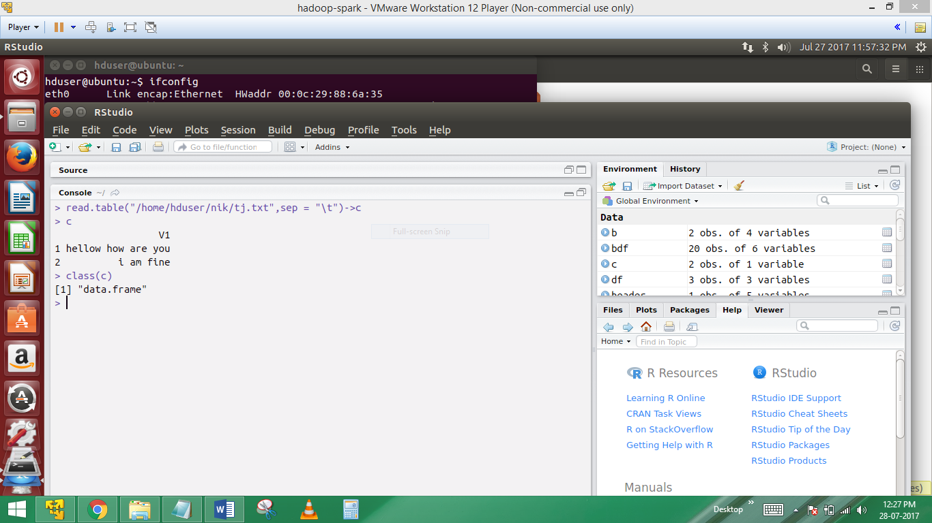

Here class of c is Class(c)

“Data.frame”

-------------------------------------------------Importing XML files----------------------------------

63)Load the required libraries

Library(XML)

Library(methods)

Mydf=xmlToDataframe(“/home/hduser/nik/theja.xml”)

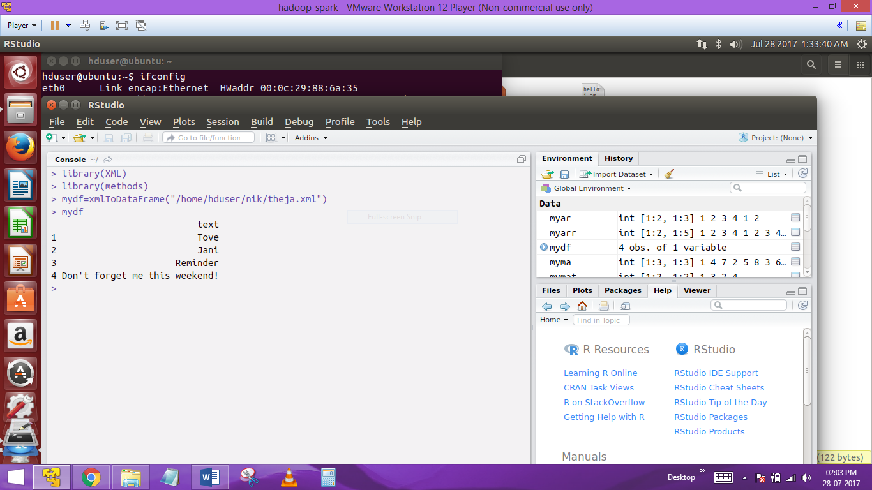

Create one xml file in home page, and assign to xml file in library(XML)…